### Large Print

### Christ Church United Methodisthttp://spartafumc.org/clientimages/45879/methodist%20cross.jpg

Connect with us online at

[www.ccumtucson.org](http://www.ccumtucson.org) [www.facebook/CCUM.Tucson](http://www.facebook/CCUM.Tucson)

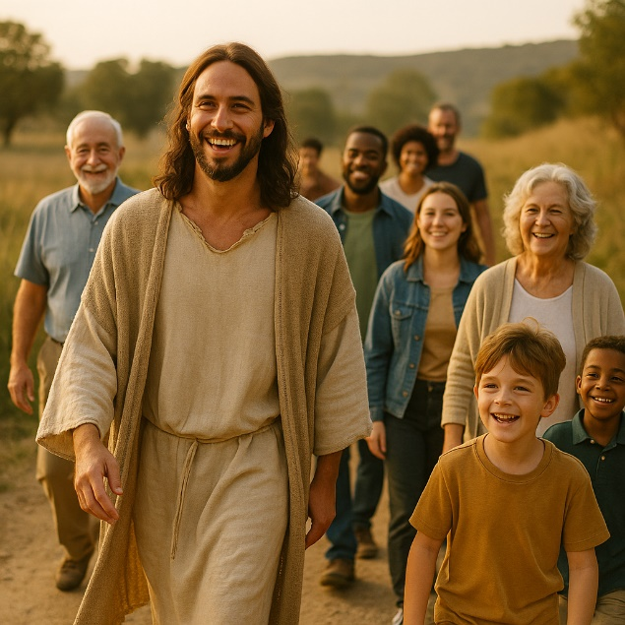

Thirteenth Sunday after Pentecost | September 7th, 2025

*Please stand as you are able

**Welcome and Announcements**

Trinity Chimes

**Prelude** *Simple Gifts*

arr. Anna Laura Page

Dylan Cook, flute

*Call to Worship

One: What we plant takes root, what we build stands.

All: So, how we plant and build matters.

One: God calls us to hear and act on the good news of Christ.

All: Lord, let the fruit of our lives,

One: The soil of our souls,

All: Be rooted and grounded in the rock of your love!

*Hymn of Praise 2042 *How Lovely, Lord, How Lovely* MERLE'S TUNE

1. How lovely, Lord, how lovely is your abiding place; my soul is longing, fainting, to feast upon your grace.

The sparrow finds - a shelter, a place to build her nest; and so your temple calls us within its walls to rest.

2. In your blest courts to worship, O God, a single day is better than a thousand if I from you should stray.

I'd rather keep the entrance and claim you as my Lord than revel in the riches the ways of sin afford.

3. A sun and shield forever are you, O God most high; you shower us with blessings no good will you deny.

The saints, your grace receiving,

from strength to strength shall go,

and from their life shall rivers of blessings overflow.

**Opening Prayer:**

**O God, our help in ages past, the church’s one foundation is Jesus Christ our Lord. Remind us again that you are our Rock of Ages, cleft for us. So, Spirit of the Living God, fall afresh on us, and let us walk by faith not just by sight. Amen.**

Words taken from popular hymns in the United Methodist Hymnal.

**Scripture Reading** Psalm 15

O Lord, who shall abide in your tent?  
    Who shall dwell on your holy hill?

**The one who walk blamelessly and does what is right,  
    and speaks the truth from the heart;**who do not slander with the tongue  
    and does no evil to a friend,  
nor takes up a reproach against a neighbor; **in whose eyes a reproach is despised**  
**but who honors those who fear the Lord;**  
who do not put out money at interest,  
    and do not take a bribe against the innocent.

**The one who does these things shall never be moved.**

**Children’s Moment**

*All children are invited to come up to the front. When we finish, they are invited to Sunday School. Pick up is after worship in the quad near classrooms 15 and 16. All are welcome.*

**Music of Preparation**  *The Image of God* Craig Courtney

Dylan Cook, flute

The Chancel Choir

Gospel Lesson Luke 6:43-49

Sermon Walking the walk: Walk the Talk Rev. Beth Rambikur

Music of Response

*Passing of the Peace

Invitation to Offering

Offertory *Deep River* arr. Anna Laura Page

Dylan Cook, flute

*Doxology 94 *Praise God, from Whom all Blessings Flow*

Praise God, from whom all blessings flow;

Praise God, all creatures here below: Alleluia! Alleluia!

Praise God, the source of all our gifts!

Praise Jesus Christ, whose power up lifts!

Praise the Spirit, Holy Spirit!

Alleluia! Alleluia! Alleluia!

*Offertory Prayer

**\*Holy Communion**

The Lord be with you.

**And also with you.**

Lift up your hearts.

We lift them up to the Lord.

Let us give thanks to the Lord our God.

It is right to give our thanks and praise.

It is right, and a good and joyful thing, always and everywhere to give thanks to you, Almighty God, creator of heaven and earth.

You shaped us from the dust of the earth and breathed life into us, forming humanity in your image. And so, with your people on earth and all the company of heaven we praise your name and join their unending hymn:

**Holy, holy, holy Lord, God of power and might, Heaven and earth are full of your glory. Hosanna in the highest. Blessed is he who comes in the name of the Lord. Hosanna in the highest.**

Holy are you, and blessed is your Son Jesus Christ. By the baptism of his suffering, death, and resurrection you gave birth to your Church, delivered us from our slavery to sin and death, and made with us a new covenant by water and the Spirit.

On the night in which he gave himself up for us, he took bread, gave thanks to you, broke the bread, gave it to his disciples, and said: "Take, eat; this is my body which is given for you. Do this in remembrance of me."

When the supper was over he took the cup, gave thanks to you, gave it to his disciples, and said: "Drink from this, all of you; this is the new covenant, poured out for you and for all for the forgiveness of sins. Do this, as often as you drink it, in remembrance of me."

And so, in remembrance of these your mighty acts in Jesus Christ, we offer ourselves in praise and thanksgiving as a holy and living sacrifice, in union with Christ's offering for us, as we proclaim the mystery of faith.

Christ has died; Christ is risen; Christ will come again.

Pour out your Holy Spirit on us gathered together, and on these gifts of food and drink. Make them be for us the body and blood of Christ, that we may be for the world the body of Christ, redeemed by his love.

By your Spirit make us one with Christ, one with each other, and one in ministry to all the world until Christ comes in final victory, and we feast at his heavenly banquet.

Through your Son Jesus Christ, with the Holy Spirit in your holy Church, all honor and glory is yours, almighty Father (God), now and forever.

Amen!

**Communion Hymn** 2030 *The First Song of Isaiah* FIRST SONG

(Sing 3 times)

Surely it is God who saves me;

I will trust in him and not be afraid.

For the Lord is my stronghold

and my sure defense,

And he will be my Savior.

The Lord’s Prayer:

Our Father, who art in heaven, hallowed be thy name. Thy kingdom come, thy will be done, on earth as it is in heaven. Give us this day our daily bread and forgive us our trespasses as we forgive those who trespass against us, and lead us not into temptation, but deliver us from evil, for thine is the kingdom and the power and the glory forever. Amen

**\*Sending Hymn** 368 *My Hope Is Built*

THE SOLID ROCK

1. My hope is built on nothing less

than Jesus’ blood and righteousness.

I dare not trust the sweetest frame,

but wholly lean on Jesus’ name.

**REFRAIN:**

On Christ the solid rock I stand,

all other ground is sinking sand;

all other ground is sinking sand.

2. When darkness veils his lovely face,

I rest on his unchanging grace.

In every high and stormy gale,

my anchor holds within the veil.

**REFRAIN**

3. His oath, his covenant, his blood

support me in the whelming flood.

When all around my soul gives way,

he then is all my hope and stay.

**REFRAIN**

*Benediction

May the Lord bless you and keep you. May the Lord make his face shine upon you and be gracious unto you. May the Lord lift up his countenance upon you and give you peace.

Postlude *Toccatina* Alejandro D. Consolacion II

Thank you to all of the volunteers and staff who made this service possible!

Liturgist: Ellie Adams

Stephen Minister: Georgia Carmichael

Golf Cart Drive: Henry Parra

ONE LICENSE A-738133 | CCLI #12393 | Perform Music #662 | CVLI #03793174

“How Lovely, Lord, How Lovely”

Words: Arlo Duba (Ps. 84)

“The First Song of Isaiah”

Words: From The Fook of Common Prayer, Canticle 9 (Isa. 12:2-6)

“My Hope Is Built”

Words: Edward Mote, 1834

If you have any questions, please call the office: 520.327.1116 or

send us an e-mail: [office@ccumtucson.org](mailto:office@ccumtucson.org).

Staff contact information (Only staff with church emails are listed)

John Neve - Bell Choir Director

[john@ccumtucson.org](mailto:john@ccumtucson.org)

Janet Tolman – Organist

janet@ccumtucson.org

Sinamar Respicio – Choir Director

[choir@ccumtucson.org](mailto:choir@ccumtucson.org)

Mary Beth Buttler – Communications

communications@ccumtucson.org

Candi Eppley – Office Administrator

[office@ccumtucson.org](mailto:office@ccumtucson.org)

Rev. Beth Rambikur

[pastor@ccumtucson.org](mailto:pastor@ccumtucson.org)