Large Print
Christ Church United Methodist
Connect with us online at
www.ccumtucson.org www.facebook/CCUM.Tucson

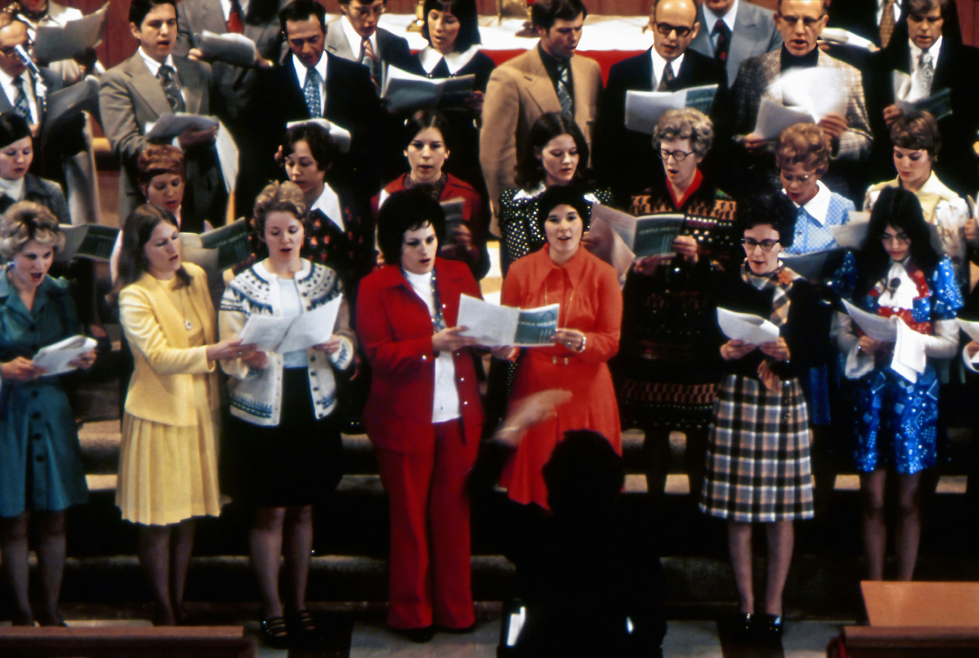
10th Sunday after Pentecost, August 17th, 2025

Welcome and Announcements

*Please stand

Trinity Chimes

Prelude Promised Land Lani Smith

*Call to Worship
One: Make a joyful noise to the Lord, all the earth.
All: Serve the Lord with gladness; come into his presence with singing.
One: Enter his gates with Thanksgiving and his courts with praise.
All: Give thanks to God, bless the name of the Lord!

*Hymn of Praise 2001 We Sing to You, O God DARWALL'S 148th
1. We sing to you, O God, the Rock who gave us birth, let our rejoicing sing your name in all the earth. To you, O God, let songs be raised in joyful hymns, our feast of praise.

2. We wandered far from home out in a desert land, you shielded with your love our fearful pilgrim band. You kept us safe with in your arms and sheltered us against the storm.

3. You bear us through the world, an eagle to her young, who rises on her wings and bears us toward the sun.
We ride the vaults of light and air
and trust in your unfailing care.

4. O God, eternal God, we hide within your wings, the everlasting arms to whom our praises ring. Your word is true, your way is just, you are the God in whom we trust.

Scripture Lesson Psalm 95
O come, let us sing to the Lord;
let us make a joyful noise to the rock of our salvation!
Let us come into God’s presence with thanksgiving;
let us make a joyful noise to him with songs of praise!
For the Lord is a great God
and a great Ruler above all gods.
in whose hand are the depths of the earth;
and also the heights of the mountains.
The sea is his, for he made it,
and the dry land, because God formed it.
O come, let us worship and bow down;
let us kneel before the Lord, our Maker!
For Lord is our God,
and we are the people of God’s pasture
and the sheep of God’s hand.
Here the voice of the Lord today!
Harden not your hearts, as at Meribah,
as on the day at Massah in the wilderness,
when your forebears tested me
and put me to the proof, though they had seen my work.
For forty years I loathed that generation
and said, “They are a people who err in heart, and they do not regard my ways.”
Therefore I swore in my anger,
tha they shall not enter my rest.”

Introduction to Hymn 380 There's Within My Heart a Melody
SWEETEST NAME
1. There's within my heart a melody
Jesus whispers sweet and low:
Fear not, I am with thee, peace, be still,
in all of life's ebb and flow.

REFRAIN
Jesus, Jesus, Jesus, sweetest name I know, fills my every longing, keeps me singing as I go.

2. All my life was wrecked by sin and strife, discord filled my heart with pain;
Jesus swept across the broken strings,
stirred the slumbering chords again.
REFRAIN

4. Feasting on the riches of his grace,
resting neath his sheltering wing,
always looking on his smiling face,
that is why I shout and sing.
REFRAIN

Prayers of the People

Confession and Pardon

Merciful God, we confess that we have not loved you with our whole heart. We have failed to be an obedient church. We have not done your will, we have broken your law, we have rebelled against your love, we have not loved our neighbors,
and we have not heard the cry of the needy. Forgive us, we pray. Free us for joyful obedience, through Jesus Christ our Lord. Amen.

Pastor: Hear the Good News, Christ is among us renewing us for life with love. In the name of Christ, you are forgiven!

People: In the name of Christ you are forgiven!

All: Glory to God, Amen.

Lord’s Prayer

Our Father, who art in heaven, hallowed be thy name. Thy kingdom come, thy will be done, on earth as it is in heaven. Give us this day our daily bread and forgive us our trespasses as we forgive those who trespass against us, and lead us not into temptation, but deliver us from evil, for thine is the kingdom and the power and the glory forever. Amen.

Open Hymn Sing

*Passing of the Peace

Invitation to Offering

Offertory Children of the Heavenly Father arr. Don Hustad

*Doxology 94 Praise God, from Whom all Blessings Flow

Praise God, from whom all blessings flow;

Praise God, all creatures here below: Alleluia! Alleluia!

Praise God, the source of all our gifts!

Praise Jesus Christ, whose power uplifts!

Praise the Spirit, Holy Spirit!

Alleluia! Alleluia! Alleluia!

*Offertory Prayer

*Closing Hymn 77 How Great Thou Art
HOW GREAT THOU ART
1. O Lord my God! When I in awesome wonder Consider all the worlds thy hands have made, I see the stars, I hear the rolling thunder, Thy power throughout the universe displayed.

REFRAIN
Then sings my soul, my Savior God to thee;
How great thou art, how great thou art!
Then sings my soul, my Savior God to thee;
how great thou art, how great thou art!

2. When through the woods and forest glades I wander, And hear the birds sing sweetly in the trees; When I look down from lofty mountain grandeur And hear the brook, and feel the gentle breeze;
REFRAIN

4.When Christ shall come with shout of acclamation and take me home, what joy shall fill my heart. Then I shall bow in humble adoration, and there proclaim, my God, how great thou art!
REFRAIN

*Benediction

May the Lord bless you and keep you. May the Lord make his face shine upon you and be gracious unto you. May the Lord lift up his countenance upon you and give you peace

Postlude Fugue and Harmonization on ST. ANNE Hal H. Hopson

Liturgist: Beth Rambikur

Stephen Minister: Gretchen Lofgren

Golf Cart Driver: Don Waugaman

Thank you to all the staff and volunteers who made this service possible!

ONE LICENSE A-738133 | CCLI #12393 | Perform Music #662 | CVLI #03793174

“We Sing to You, O God”

Words: Gracia Grindal (Deut. 32:11, 18; 33:27; Ps. 57:1;66:2; 96:1-2

“There’s Within My Heart a Melody”

Words: Luther B. Bridgers, 1910

“How Great Thou Art”

Words: Stuart K. Hine, 1953

If you have any questions, please call the office: 520.327.1116 or

send us an e-mail: office@ccumtucson.org.

Staff contact information (Only staff with church emails are listed)

John Neve - Bell Choir Director

john@ccumtucson.org

Janet Tolman – Organist

janet@ccumtucson.org

Sinamar Respicio – Choir Director

choir@ccumtucson.org

Mary Beth Buttler – Communications

communications@ccumtucson.org

Candi Eppley – Office Administrator

office@ccumtucson.org

Rev. Beth Rambikur

pastor@ccumtucson.org

