Large Print
Christ Church United Methodist
Connect with us online at
www.ccumtucson.org www.facebook/CCUM.Tucson

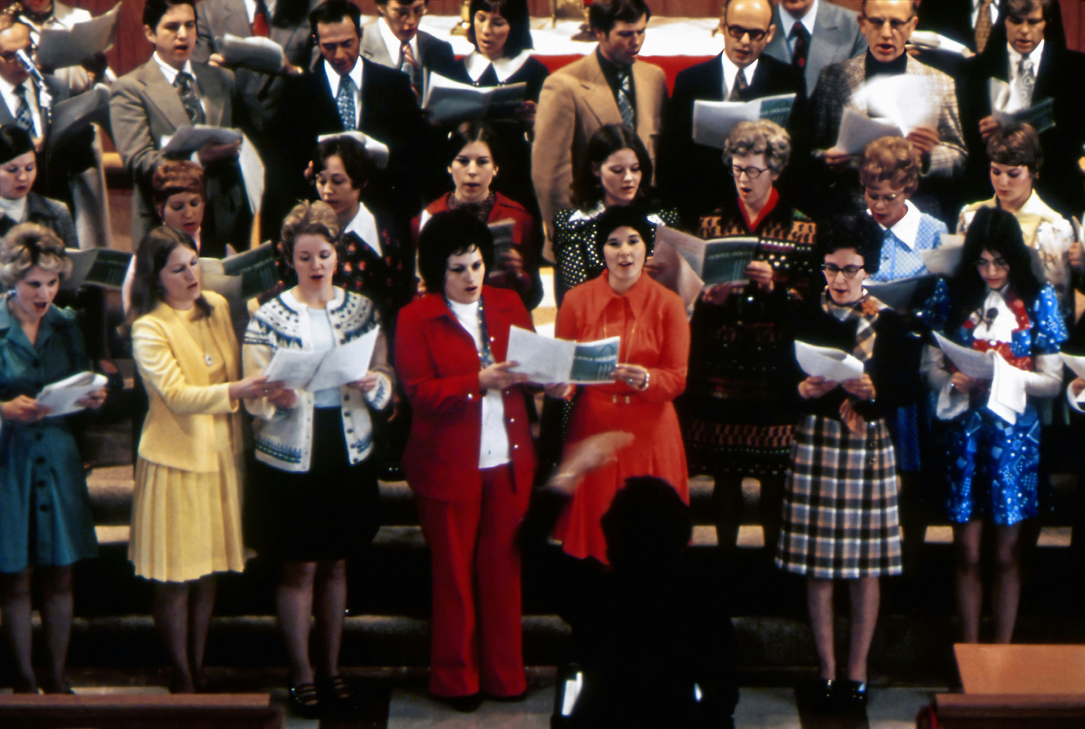
3rd Sunday after Pentecost, June 29th, 2025

Welcome and Announcements

*Please stand

Trinity Chimes

Prelude Elegy G.T. Thalben-Ball

*Call to Worship
One: Make a joyful noise to the Lord, all the earth.
All: Serve the Lord with gladness; come into his presence with singing.
One: Enter his gates with Thanksgiving and his courts with praise.
All: Give thanks to God, bless the name of the Lord!

*Hymn of Praise 126 Sing Praise to God Who Reigns Above

MIT FREUDEN ZART

1. Sing praise to God who reigns above,

the God of all creation,

the God of power, the God of love,

the God of our salvation.

With healing balm my soul is filled

and every faithless murmur stilled:

To God all praise and glory.

2. The Lord is never far away,

but through all grief distressing,

an ever-present help and stay,

our peace and joy and blessing.

As with a mother’s tender hand,

God gently leads the chosen band:

To God all praise and glory.

3. Thus, all my toilsome way along,

I sing aloud thy praises,

that earth may hear the grateful song

my voice unwearied raises.

Be joyful in the Lord, my heart,

both soul and body bear your part:

To God all praise and glory.

4. Let all who name Christ’s holy name

give God all praise and glory;

let all who own his power proclaim

aloud the wondrous story!

Cast each false idol from its throne,

for Christ is Lord, and Christ alone:

To God all praise and glory.

Scripture Lesson Psalm 98

O sing to the Lord a new song,

For the Lord has done marvelous things! God’s right hand and holy arm

have gotten the victory.

The Lord has declared victory,

and has revealed his vindication in the sight of the nations.

The Lord has remembered his steadfast love and faithfulness to the house of Israel.

All the ends of the earth have seen

the victory of our God.

Make a joyful noise to the Lord, all the earth;

break forth into joyous song and sing praise!

Sing praises to the Lord with the lyre,

with the lyre and the sound of melody!

With trumpets and the sound of the horn

make a joyful noise before the Ruler, the Lord!

Let the sea roar, and all that fills it,

the world and those who dwell in it!

Let the floods clap their hands;

let the hills sing for joy together before the Lord, who comes to judge the earth. The Lord will judge the world with righteousness, and the peoples with equity.

Introduction to Hymn Sing Creation Sings
LONDONDERRY AIR
1. Creation sings! And we are in the music,
the movement of God's energy and art,
a liturgy that links our life to angels,
a litany that rises from the heart.
The Spirit sings!
Through love and lamentation,
from Pentecost to joy of Easter Day
the universe is resonant with music,
the smallest creature dances to its play.

2. Creation groans at our discordant clashing; the Spirit comes with music as our friend to bring the harmony of peace and beauty, to teach the textures of the way to blend. O God, you draw the melody from silence, you make of us the instruments of song! We offer thanks in worship and in wonder
that such a gift to human souls belong.

Prayers of the People

Confession and Pardon
Holy God, hear our prayer. There is pain and there is sorrow, there are broken relationships and broken hearts. Sometimes we are the cause of those things. We have caused pain. We have broken the relationship. Sometimes we are simply a part of them – we are the ones who suffer, we are the ones who are broken. So we ask for your forgiveness, and we ask for your healing. Beyond that, we ask that you would help us turn from our former selves to the persons you have created us to be, full of mercy and grace and love. Through Christ, who is our example, we pray. Amen.
Written by Beth Merrill Neel on her blog, “Hold Fast to What Is Good.” Used with permission. Posted at https://holdfasttowhatisgood.com/liturgy/prayer-of-confession/.

Pastor: Hear the Good News, Christ is among us renewing us for life with love. In the name of Christ, you are forgiven!

People: In the name of Christ you are forgiven!

All: Glory to God, Amen.

Lord’s Prayer

Our Father, who art in heaven, hallowed be thy name. Thy kingdom come, thy will be done, on earth as it is in heaven. Give us this day our daily bread and forgive us our trespasses as we forgive those who trespass against us, and lead us not into temptation, but deliver us from evil, for thine is the kingdom and the power and the glory forever. Amen.

Open Hymn Sing

*Passing of the Peace

Invitation to Offering

Offertory Blest Be the Tie That Binds Us Together arr. Mark Hayes

*Doxology 94 Praise God, from Whom all Blessings Flow

Praise God, from whom all blessings flow;

Praise God, all creatures here below: Alleluia! Alleluia!

Praise God, the source of all our gifts!

Praise Jesus Christ, whose power uplifts!

Praise the Spirit, Holy Spirit!

Alleluia! Alleluia! Alleluia!

*Offertory Prayer

*Closing Hymn 600 Wonderful Words of Life WORDS OF LIFE

1. Sing them over again to me,
wonderful words of life;
Let me more of their beauty see,
wonderful words of life;
Words of life and beauty
teach me faith and duty.
REFRAIN
Beautiful words, wonderful words, wonderful words of life.
Beautiful words, wonderful words, wonderful words of life.

3. Sweetly echo the gospel call,
wonderful words of life;
Offer pardon and peace to all,
wonderful words of life;
Jesus, only Savior, sanctify forever.
REFRAIN

*Benediction

May the Lord bless you and keep you. May the Lord make his face shine upon you and be gracious unto you. May the Lord lift up his countenance upon you and give you peace

Postlude Trumpet Tune

Frederick Swann

Liturgist: Iris Washburn

Stephen Minister: Bob Stoebe

Golf Cart Driver: Tom Haslag

Thank you to all the staff and volunteers who made this service possible!

ONE LICENSE A-738133 | CCLI #12393 | Perform Music #662 | CVLI #03793174

“Sing Praise to God Who Reigns Above”

Words: Johann J Schutz, 1675; trans by Frances E Cox, 1864 (Dt. 32:3)

“Creation Sings”

Words: Shirley Erena Murray

“Wonderful Words of Life”

Words: Philip P Bliss, 1874

