### Large Print

### Christ Church United Methodisthttp://spartafumc.org/clientimages/45879/methodist%20cross.jpg

Connect with us online at

[www.ccumtucson.org](http://www.ccumtucson.org) [www.facebook/CCUM.Tucson](http://www.facebook/CCUM.Tucson)

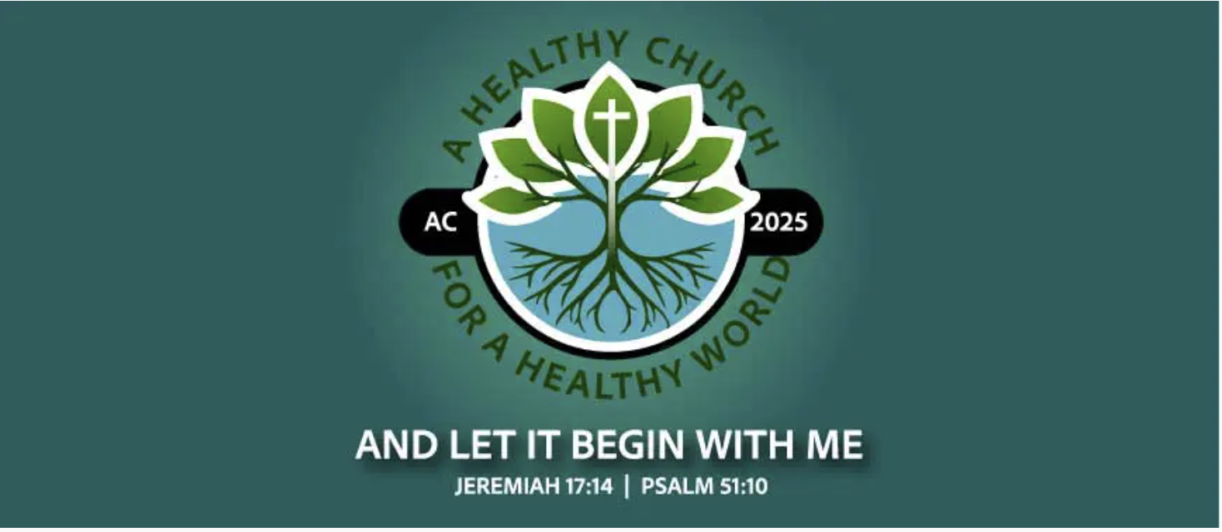

Second Sunday after Pentecost **|** June 22nd, 2025

*Please stand as you are able

**Welcome and Announcements**

Trinity Chimes

**Prelude**  *Little Suite on CWM RHONDDA*

Janet Tolman

*Call to Worship

One: Come, people of God, with hearts open to renewal and healing.  
All: Restore us, O Lord, and make us whole, for you are our strength and our song.  
One: Move, Spirit, move—sweep through us with your hope.  
All: Christ, live in us, that we might be your hands and feet.  
One: Lord, heal the world!  
All: And let it begin with me.

*Hymn of Praise 127 *Guide Me, O Thou Great Jehovah* CWM RHONDDA

1. Guide me, O thou great Jehovah,

pilgrim through this barren land.

I am weak, but thou art mighty;

Hold me with thy powerful hand.

Bread of heaven, bread of heaven,

Feed me till I want no more;

feed me till I want no more.

2. Open now the crystal fountain,

Whence the healing stream doth flow;

Let the fire and cloudy pillar

Lead me all my journey through.

Strong deliverer, strong deliverer,

Be thou still my strength and shield;

be thou still my strength and shield.

3. When I tread the verge of Jordan,

Bid my anxious fears subside;

Death of death and hell's destruction,

Land me safe on Canaan's side.

Songs of praises, songs of praises,

I will ever give to thee;

I will ever give to thee.

Opening Prayer

**Healing God, you meet us in the places we least expect – among tombs, in storms, in silence, even fear. You speak peace to our demons and restore us to our right minds. Set us free from all that binds us. Clothe us with your grace and send us to all the world so that healing might begin with us. Amen.**

**Scripture Reading** Psalm 42

As a deer longs for flowing streams,  
    so my soul longs for you, O God.  
**My soul thirsts for God,  
    for the living God.  
When shall I come and behold  
    the face of God?**  
My tears have been my food  
    day and night,  
while people say to me continually,  
    “Where is your God?”

**These things I remember,  
    as I pour out my soul:  
how I went with the throng  
    and led them in procession to the house of God,  
with glad shouts and songs of thanksgiving,  
    a multitude keeping festival.**Why are you cast down, O my soul,  
    and why are you disquieted within me?  
**Hope in God, for I shall again praise him,  
 my help and my God.**

My soul is cast down within me;  
    therefore I remember you  
from the land of Jordan and of Hermon,  
    from Mount Mizar.  
**Deep calls to deep  
    at the thunder of your torrents;  
all your waves and your billows  
    have gone over me.**By day the Lord commands his steadfast love, and at night his song is with me,  
    a prayer to the God of my life.

**I say to God, my rock,  
    “Why have you forgotten me?  
Why must I walk about mournfully  
    because the enemy oppresses me?”**  
As with a deadly wound in my body,  
    my adversaries taunt me,  
while they say to me continually,  
    **“Where is your God?”**

Why are you cast down, O my soul,  
    and why are you disquieted within me?  
**Hope in God, for I shall again praise him,  
    my help and my God**.

**Music of Preparation** 2158 *Just a Closer Walk with Thee* CLOSER WALK

1. I am weak, but thou art strong;

Jesus, keep me from all wrong;

I'll be satisfied as long

as I walk, let me walk close to thee

**REFRAIN**

Just a closer walk with thee, grant it, Jesus, is my plea,

Daily walking close to thee; Let it be, dear Lord, let it be.

2. Through this world of toil and snares,

If I falter, Lord who cares?

Who with me my burden shares?

None but thee, dear Lord, none but thee.

**REFRAIN**

3. When my feeble life is o'er,

Time for me will be no more;

Guide me gently, safely o'er

To thy shore, dear Lord, to thy shore.

**REFRAIN**

Gospel Lesson Luke 8:26-39

Message Lord, heal the world! And let it begin with us.

Kara Ford and Michael Edwards

Music of Response

Prayers of the People

Confession and Pardon

**Merciful God, we confess that we have not loved you with our whole heart. We have failed to be an obedient church. We have not done your will, we have broken your law, we have reveled against your love, we have not loved our neighbors, and we have not heard the cry of the needy. Lord, heal the world and let it begin with us. Forgive us and open us to your transforming wholeness. Amen.**

Pastor:  Hear the Good News, Christ is among us renewing us for life with love.  In the name of Christ, you are forgiven!

**People: In the name of Christ you are forgiven!**

**All: Glory to God, Amen.**

The Lord’s Prayer:

Our Father, who art in heaven, hallowed be thy name. Thy kingdom come, thy will be done, on earth as it is in heaven. Give us this day our daily bread and forgive us our trespasses as we forgive those who trespass against us, and lead us not into temptation, but deliver us from evil, for thine is the kingdom and the power and the glory forever. Amen

*Passing of the Peace

*Invitation to Offering

Offertory *Take my life and let it be*

Alejandro D. Consolacion II

Sinamar Respicio, solo

*Doxology 94 *Praise God, from Whom all Blessings Flow*

Praise God, from whom all blessings flow;

Praise God, all creatures here below: Alleluia! Alleluia!

Praise God, the source of all our gifts!

Praise Jesus Christ, whose power up lifts!

Praise the Spirit, Holy Spirit!

Alleluia! Alleluia! Alleluia!

*Offertory Prayer

**\*Sending Hymn**  431 *Let There Be Peace on Earth*

WORLD PEACE

Let there be peace on earth, and let it begin with me; Let there be peace on earth,

the peace that was meant to be.

With God our creator, children all are we.

Let us walk with each other in perfect harmony.

Let peace begin with me; let this be the moment now. With every step I take, let this be my solemn vow; To take each moment and live each moment in peace eternally.

Let there be peace on earth, and let it begin with me.

**\*Benediction**

The Lord bless you and keep you; the Lord make his face to shine upon you, and be gracious to you; the Lord lift up his countenance upon you, and give you peace. Amen.

Postlude *Trumpet Play* Norman Warren

Thank you to all of the volunteers and staff who made this service possible!

Liturgist: Kara Ford and Michael Edwards

Stephen Minister: Georgia Carmichael

Golf Cart Drive: Don Waugaman

ONE LICENSE A-738133 | CCLI #12393 | Perform Music #662 | CVLI #03793174

“Guide Me, O Thou Great Jehovah”

Words: William, Williams, 1745; trans. from Welsh by Peter Williams and the author, 1771

“Just a Closer Walk with Thee”

Words: Anon. (James 4:8)

“Let There Be Peace on Earth”

Words: Sy Miller and Jill Jackson

If you have any questions, please call the office: 520.327.1116 or

send us an e-mail: [office@ccumtucson.org](mailto:office@ccumtucson.org).

Staff contact information (Only staff with church emails are listed)

John Neve - Bell Choir Director

[john@ccumtucson.org](mailto:john@ccumtucson.org)

Janet Tolman – Organist

janet@ccumtucson.org

Sinamar Respicio – Choir Director

[choir@ccumtucson.org](mailto:choir@ccumtucson.org)

Mary Beth Buttler – Communications

communications@ccumtucson.org

Candi Eppley – Office Administrator

[office@ccumtucson.org](mailto:office@ccumtucson.org)

Rev. Beth Rambikur

[pastor@ccumtucson.org](mailto:pastor@ccumtucson.org)