### Christ Church United Methodisthttp://spartafumc.org/clientimages/45879/methodist%20cross.jpg

**Large Print Bulletin**

Connect with us online at

[www.ccumtucson.org](http://www.ccumtucson.org) [www.facebook/CCUM.Tucson](http://www.facebook/CCUM.Tucson)

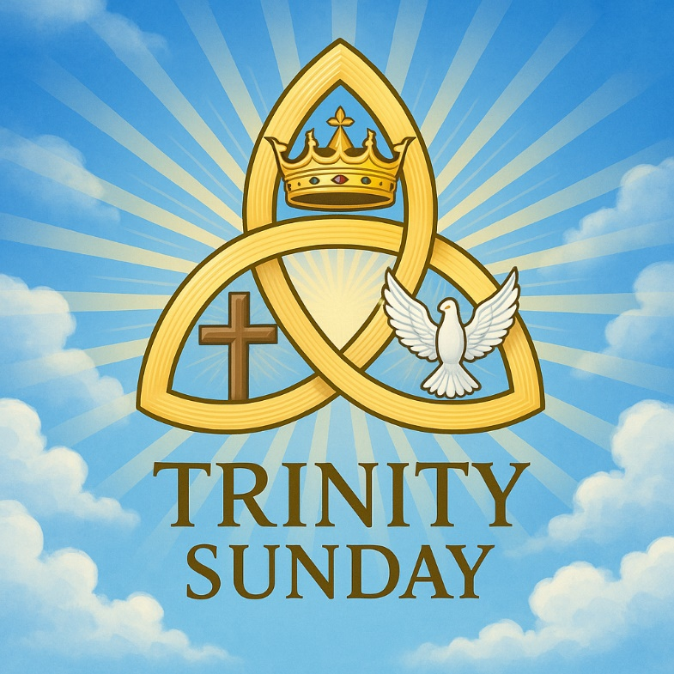

Trinity Sunday| June 15th, 2025

*Please stand as you are able

**Welcome and Announcements**

Trinity Chimes

**Prelude**  *Holy, Holy, Holy* (with *Concerto #2 in C Minor* by Rachmaninoff) arr. McKechnie Kathy Ferguson, piano: Janet Tolman, organ

*Call to Worship

One: We come today to worship God the Father, God the Son, and God the Holy Spirit. We worship God, the Creator.

All: Praise be to God for creating all life.

One: We worship God, the Son.

All: Thanks be to God for sending the Son for our redemption.

One: We worship God, the Holy Spirit.

All: Thanks be to God for sending us the Spirit of Truth to guide us. Let us worship our triune God.

*Hymn of Praise *64 Holy, Holy, Holy! Lord God Almighty*

NICAEA

1. Holy, holy, holy! Lord God Almighty!

Early in the morning our song shall rise to thee.

Holy, holy, holy! Merciful and mighty

God in three persons, blessed Trinity

2. Holy, holy, holy!

All the saints adore thee,

Casting down their golden crowns

around the glassy sea;

Cherubim and seraphim falling

down before thee,

Which wert, and art, and evermore shalt be.

3. Holy, holy, holy!

Though the darkness hide thee,

Though the eye of sinful man

thy glory may not see,

Only thou art holy; there is none beside thee,

Perfect in power, in love and purity.

4, Holy, holy, holy!

Lord God Almighty!

All thy works shall praise thy name,

in earth and sky and sea.

Holy, holy, holy! Merciful and mighty,

God in three persons, blessed Trinity.

Opening Prayer

**Loving God, creator of all, who sent the Spirit to dwell within us. We Praise your Holy name. Give us hearts and minds to open our lives to you, to receive your word and your truth. May we follow the Holy Spirit that is within us and give glory to you in all that we do. Amen.**

**Scripture Reading** Psalm 8 (UMH 743)

O Lord, our Lord,  
**how majestic is your name in all the earth!**

Your glory is chanted above the heavens.  
    by the mouths of babes and infants  
**you have set up a defense against your foes,  
    to still the enemy and the avenger.**

When I look at your heavens, the work of your fingers,  
    **the moon and the stars that you have established;**what are human beings that you are mindful of them,  
    **and mortals that you care for them?**

Yet you have made them little less than God,  
    **and crowned them with glory and honor.**  
You have given them dominion over the works of your hands;  
    **you have put all things under their feet,**  
all sheep and oxen,  
    **and also the beasts of the field,**the birds of the air, and the fish of the sea,  
    **whatever passes along the paths of the seas.**

O Lord, our Lord,  
    **how majestic is your name in all the earth!**

**Music of Preparation** 544 *Like the Murmur of the Dove's Song*

BRIDEGROOM

1. Like the murmur of the dove's song,

like the challenge of her flight,

Like the vigor of the wind's rush,

like the new flame's eager might:

Come, Holy Spirit, come.

2. To the members of Christ's body,

to the branches of the Vine,

To the church in faith assembled,

to her midst as gift and sign:

Come, Holy Spirit, come.

3. With the healing of division,

With the ceaseless voice of prayer,

with the power to love and witness,

with the peace beyond compare:

Come, Holy Spirit, come.

Gospel Lesson John 14: 8-17, 25-27

Sermon Three in One: Holy, Holy, Holy Paula Jameson

Music of Response

Prayers of the People

Confession and Pardon

**Almighty and all–loving God, through your Son Jesus Christ you have reconciled the world to yourself. Help us now to be reconciled with one another, that again we might dwell in the warmth of your love. Inspire us with your Holy Spirit to put aside the cloak of pride and put on Christ, that we might forgive and be forgiven; through Jesus Christ our Lord. Amen.**

(MICHAEL J. O’DONNELL, U.S.A., 20TH CENT.)

Pastor:  Hear the Good News, Christ is among us renewing us for life with love.  In the name of Christ, you are forgiven!

**People: In the name of Christ you are forgiven!**

**All: Glory to God, Amen.**

The Lord’s Prayer:

Our Father, who art in heaven, hallowed be thy name. Thy kingdom come, thy will be done, on earth as it is in heaven. Give us this day our daily bread and forgive us our trespasses as we forgive those who trespass against us, and lead us not into temptation, but deliver us from evil, for thine is the kingdom and the power and the glory forever. Amen

*Passing of the Peace

*Invitation to Offering

Offertory *Fairest Lord Jesus*

arr. Smith & Hustad

Kathy Ferguson, piano; Janet Tolman, organ

*Doxology 94 *Praise God, from Whom all Blessings Flow*

Praise God, from whom all blessings flow;

Praise God, all creatures here below: Alleluia! Alleluia!

Praise God, the source of all our gifts!

Praise Jesus Christ, whose power up lifts!

Praise the Spirit, Holy Spirit!

Alleluia! Alleluia! Alleluia!

*Offertory Prayer

**\*Sending Hymn**  *Spirit of God*  DOVE SONG

1. Spirit of God, bright Wind, breath that bids life begin,

blow as you always do; create us anew.

Give us the breath to sing, lifted on soaring wing, held in your hands, borne on your wings, Alleluia! Come, Spirit, come!

2. Spirit of God, bright Dove, grant us your peace and love, healing upon your wings for all living things. For when we live your peace, captives will find release, held in your hands, borne on your wings, Alleluia! Come, Spirit, come!

3, Spirit of God, bright Hands, even in far off lands you hold all the human race in one warm embrace. No matter where we go, you hold us together so, held in your hands, borne on your wings, Alleluia! Come, Spirit, come!

4. Spirit of God, bright Flame, send us in your holy name, the power to heal, to share your love everywhere. We cannot fail or fall, or know defeat at all, held in your hands, borne on your wings, Alleluia! Come, Spirit, come!

5. Spirit of God, in all, we gladly hear your call, the life in our hands that sings, the power of your wings. Born of your grace we rise, love shining in our eyes. held in your hands, borne on your wings, Alleluia! Come, Spirit, come!

**\*Benediction**

The Lord bless you and keep you; the Lord make his face to shine upon you, and be gracious to you; the Lord lift up his countenance upon you, and give you peace. Amen.

Postlude *Guide Me, O Thou Great Jehovah*

(with *Eine Kleine Nachtmusik* - Allegro by Mozart) arr. McKechnie Kathy Ferguson, piano: Janet Tolman, organ

Thank you to all of the volunteers and staff who made this service possible!

Liturgist: Dick Lear

Stephen Minister: Cat Reinke

Golf Cart Drive: Ron Thompson

ONE LICENSE A-738133 | CCLI #12393 | Perform Music #662 | CVLI #03793174

“Holy, Holy, Holy! Lord God Almighty”

Words: Reginald Heber, 1826 (Rev. 4:8-11)

“Like the Murmur of the Dove’s Song”

Words: Carl P. Daw, Jr., 1981 (Acts 2)

“Spirit of God”

Words: Steve Garnaas-Holmes (Gen 1:2; Matt 3:16-17, Luke 3:22; Acts 2:1-4)

If you have any questions, please call the office: 520.327.1116 or

send us an e-mail: [office@ccumtucson.org](mailto:office@ccumtucson.org).

Staff contact information (Only staff with church emails are listed)

John Neve - Bell Choir Director

[john@ccumtucson.org](mailto:john@ccumtucson.org)

Janet Tolman – Organist

janet@ccumtucson.org

Sinamar Respicio – Choir Director

[choir@ccumtucson.org](mailto:choir@ccumtucson.org)

Mary Beth Buttler – Communications

communications@ccumtucson.org

Candi Eppley – Office Administrator

[office@ccumtucson.org](mailto:office@ccumtucson.org)

Rev. Beth Rambikur

[pastor@ccumtucson.org](mailto:pastor@ccumtucson.org)