### Large Print

### Christ Church United Methodisthttp://spartafumc.org/clientimages/45879/methodist%20cross.jpg

Connect with us online at

[www.ccumtucson.org](http://www.ccumtucson.org) [www.facebook/CCUM.Tucson](http://www.facebook/CCUM.Tucson)

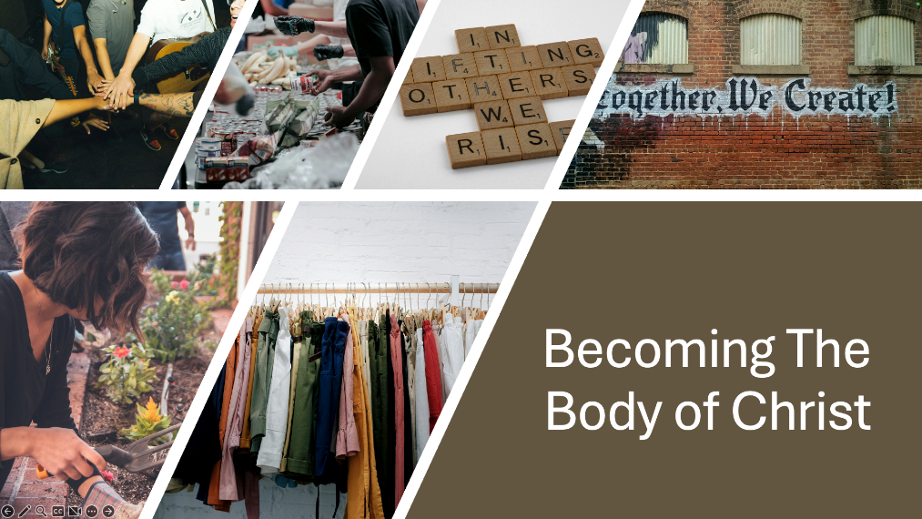

Fifth Sunday of Easter | May 18th, 2025

*Please stand as you are able

**Welcome and Announcements**

Trinity Chimes

**Prelude**  *Vision*  Josef Rheinberger

*Call to Worship

One: We come to worship God—beginning and end,  
All: Longing for the day when every tear is wiped away,  
and all creation sings praise.

One: We come to worship the One who makes all things new.

All: From sky to sea, from mountain to heartbeat, God brings a new heaven and a new earth — even now, in the midst of what is.

*Hymn of Praise 2008 *Let All Things Now Living* THE ASH GROVE

1. Let all things now living a song of thanksgiving

To God the Creator triumphantly raise,

Who fashioned and made us, protected and stayed us,

Who guides us and leads to the end of our days.

God's banners fly o'er us; God's light goes before us,

A pillar of fire shining forth in the night,

Till shadows have vanished and darkness is banished,

As forward we travel from light into light.

2. The law God enforces, the stars in their courses

And sun in its orbit obediently shines;

The hills and the mountains, the rivers and fountains,

The deeps of the ocean proclaim the Divine.

We too, should be voicing our love and rejoicing;

With glad adoration a song let us raise,

Till all things now living unite in thanksgiving:

To God in the highest hosannas and praise!

Opening Prayer

**God of new beginnings, You speak hope into the cracks of what is, drawing us near and promising life in the face of grief.**

**Make us ready to be made new, and brave enough to change.**

**Reveal to us your vision, that we may follow Christ with courage. Amen.**

**Scripture Reading** **Psalm 148**

**Music of Preparation** *For the Beauty of the Earth* John Rutter

The Chancel Choir

Scripture Lesson Revelation 21:1-6

Sermon Becoming the Body: All things new Pastor Beth

Recognition of Graduates

**James Force**\*,

Graduating from Sahuaro High School

**Juan Jimenez**\*

Graduating from Palo Verde High School

**Brooklyn Y. Jay**

Granddaughter of Gary Jay

Graduating from Flagstaff High School

**Kylie Coblentz**

Great Granddaughter of Gretchen Lofgren

Graduating from high school in Port St Lucie FL

**Tyler Belcher**

Great-grandson of Gretchen Lofgren

Graduating from High School in Pensacola FL

**Douglas Swango**

Grandson of Dan and Carol Swango

Graduating from the University of Arizona

**Courtney Acker**

Granddaughter of Gretchen Lofgren

Graduating from College in Charleston SC

**Luke Smith**

Grandson of Paula and Joe Jameson

Graduating from University of Arizona

**Confirmation and Welcome of New Member**

Music of Response *Here Within This Congregation*     BEECHER

1. Here within this congregation

God's abundance may be found:

we are blessed with gifts that differ,

skills and talents all around.

We are members of one body,

pieces vital to the whole:

Ev'ry person is important,

each one has a crucial role.

2.  Some may dance while others garden, some may draw while others teach. Some may cook or offer comfort, some may write and some may preach. Some agree while others question, some are silent, others sing.

May we never under-value gifts that fellow members bring.

3. Holy Spirit, help us treasure

talents that surround us here;

talents known and talents hidden

make us more than we appear.

Humbly, God, we sing thanksgiving,

honoring the gifts you give.

Help us always use them wisely

faithfully, each day we live.

Prayers of the People

Confession and Pardon

**Holy One, You promise a new creation — but we cling to the comfort of what we’ve always known. You offer living water — but we keep returning to dry wells. You dwell with your people — but we build walls to keep each other out. Forgive us, O God. For the fear that resists change. For the habits that silence your voice. For the ways we forget that you are already here, at work, making all things new. In mercy, remake us. In grace, renew us. In love, receive us. Amen.**

Written in collaboration with Open AI chat GPT

Pastor:  Hear the Good News, Christ is among us renewing us for life with love.  In the name of Christ, you are forgiven!

**People: In the name of Christ you are forgiven!**

**All: Glory to God, Amen.**

The Lord’s Prayer:

Our Father, who art in heaven, hallowed be thy name. Thy kingdom come, thy will be done, on earth as it is in heaven. Give us this day our daily bread and forgive us our trespasses as we forgive those who trespass against us, and lead us not into temptation, but deliver us from evil, for thine is the kingdom and the power and the glory forever. Amen

*Passing of the Peace

Invitation to Offering

Offertory *Give Me Jesus*

arr. Joe Utterback

*Doxology 94 *Praise God, from Whom all Blessings Flow*

Praise God, from whom all blessings flow;

Praise God, all creatures here below: Alleluia! Alleluia!

Praise God, the source of all our gifts!

Praise Jesus Christ, whose power up lifts!

Praise the Spirit, Holy Spirit!

Alleluia! Alleluia! Alleluia!

*Offertory Prayer

**\*Sending Hymn** 706 *Soon and Very Soon* VERY SOON

1. Soon and very soon, we are going to see the King; Soon and very soon, we are going to see the King;

Soon and very soon, we are going to see the King.

Hallelujah! Hallelujah! We're going to see the King.

2. No more dying there, we are going to see the King:

3. No more crying there, we are going to see the King.

*Benediction

We are sent forth in the power of Christ’s resurrection. Alleluia! The grace of the Lord Jesus Christ, and the love of God, and the communion of the Holy Spirit be with you all. Amen.

Postlude *Resurrexit!* Andrew Gant

Thank you to all of the volunteers and staff who made this service possible!

Liturgist: Don Finch

Stephen Minister: Carol Swango

Golf Cart Drive: Tobin Sidles

ONE LICENSE A-738133 | CCLI #12393 | Perform Music #662 | CVLI #03793174

“Let All Things Now Living”

Words: Katherine K Davis (Exod. 13:21: Ps 148; 150:6)

“Soon and Very Soon”

Words: Andraé Crouch 1978 (Rev. 21:3-4

If you have any questions, please call the office: 520.327.1116 or

send us an e-mail: [office@ccumtucson.org](mailto:office@ccumtucson.org).

Staff contact information (Only staff with church emails are listed)

John Neve - Bell Choir Director

[john@ccumtucson.org](mailto:john@ccumtucson.org)

Janet Tolman – Organist

janet@ccumtucson.org

Sinamar Respicio – Choir Director

[choir@ccumtucson.org](mailto:choir@ccumtucson.org)

Mary Beth Buttler – Communications

communications@ccumtucson.org

Candi Eppley – Office Administrator

[office@ccumtucson.org](mailto:office@ccumtucson.org)

Rev. Beth Rambikur

[pastor@ccumtucson.org](mailto:pastor@ccumtucson.org)