### Large Print

### Christ Church United Methodisthttp://spartafumc.org/clientimages/45879/methodist%20cross.jpg

Connect with us online at

[www.ccumtucson.org](http://www.ccumtucson.org) [www.facebook/CCUM.Tucson](http://www.facebook/CCUM.Tucson)

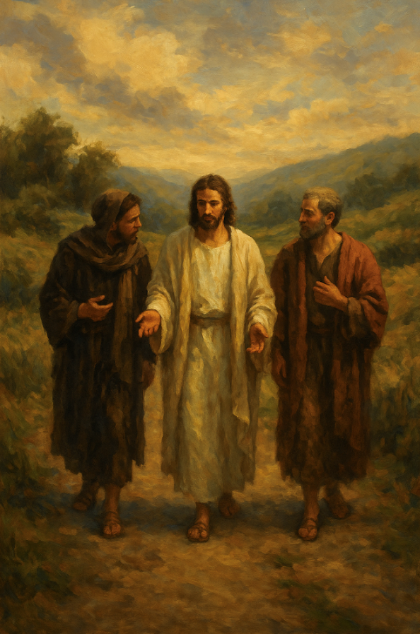

Second Sunday of Easter | April 27th, 2025

*Please stand as you are able

**Welcome and Announcements**

Trinity Chimes

**Prelude**  *Because He Lives*

Gaither/Whitworth

Kathryn Snodgrass, piano;

Janet Tolman, organ

*Call to Worship

One: Easter is the beginning of the adventure,  
All: A path we walk, a story still unfolding.  
One: Christ meets us in motion, in mystery, and in miracle.  
All: So we bring our doubts, our questions, our wonder, our everyday lives, and find Christ along the way!

*Hymn of Praise 304 Easter People, Raise Your Voices

REGENT SQUARE

1. Easter people, raise your voices,

sounds of heaven in earth should ring.

Christ has brought us heaven's choices;

Heavenly music, let it ring.

Alleluia! Alleluia! Easter people, let us sing.

2. Fear of death can no more stop us

From our pressing here below.

For our Lord empowered us

To triumph over every foe.

Alleluia! Alleluia! On to victory now we go.

3. Every day to us is Easter,

With its resurrection song.

When in trouble move the faster

To our God who rights the wrong.

Alleluia! Alleluia! See the power of heavenly throngs.

Opening Prayer

**Risen Christ, You catch up with us on the road.  You listen to our questions, you let us tell the story in our own words, then you make us whole.  As you walk with us today, surprise us with joy, set our hearts on fire again.  Meet us in our sharing, and send us back out with your story to tell.** **Amen.**

**Scripture Reading** **Psalm 150**

Praise the Lord!  
**Praise God in his sanctuary;**  
    **praise God in his mighty firmament!**   
Praise God for his mighty deeds;  
    **praise God according to his surpassing greatness**!

Praise God with trumpet sound;  
    **praise God with lute and harp!**Praise God with tambourine and dance;  
**praise God with strings and pipe!**  
Praise God with clanging cymbals;  
**praise God with loud clashing cymbals!**  
Let everything that breathes praise the Lord!  
**Praise the Lord!**

**Music of Preparation** 2196 *We Walk by Faith* MARTYRDOM

1. We walk by faith, and not by sight: No gracious words we hear of him who spoke as none e’er spoke, but we believe him near.

2. We may not touch his hands and side, nor follow where he trod; yet in his promise we rejoice, and cry, “My Lord and God!”

3. Help then, O Lord, our unbelief, and may our faith abound; to call on you when you are near, and seek where you are found:

4. That when our life of faith is done in realms of clearer light we may behold you as you are in full and endless sight.

Gospel Lesson Luke 24:13-35

Sermon Beyond the Cross Road part 2

Pastor Beth

Music of Response

Prayers of the People

Confession and Pardon

Holy God, we confess that we do not always recognize you.  In our rush, in our worry, in our doubt, we miss your presence on the road beside us.  We speak, but do not listen.  We question, but forget to wonder.  We long for proof, but overlook your quiet miracles.  Still, you walk with us.  Still, you open our hearts. Still, you break the bread and bless it.  Still, you invite us to begin again. Forgive us.  Open our eyes.  Ignite our hearts.  And walk with us—beyond the cross road, into new life. ****Amen.****

Pastor:  Hear the Good News, Christ is among us renewing us for life with love.  In the name of Christ, you are forgiven!

**People: In the name of Christ you are forgiven!**

**All: Glory to God, Amen.**

The Lord’s Prayer:

Our Father, who art in heaven, hallowed be thy name. Thy kingdom come, thy will be done, on earth as it is in heaven. Give us this day our daily bread and forgive us our trespasses as we forgive those who trespass against us, and lead us not into temptation, but deliver us from evil, for thine is the kingdom and the power and the glory forever. Amen

*Passing of the Peace

Invitation to Offering

Offertory *Oh, How He Loves You and Me*

Kaiser/Bock

Kathryn Snodgrass, piano;

Janet Tolman, organ

*Doxology 94 *Praise God, from Whom all Blessings Flow*

Praise God, from whom all blessings flow;

Praise God, all creatures here below: Alleluia! Alleluia!

Praise God, the source of all our gifts!

Praise Jesus Christ, whose power up lifts!

Praise the Spirit, Holy Spirit!

Alleluia! Alleluia! Alleluia!

*Offertory Prayer

**\*Sending Hymn** 318 *Christ Is Alive*

TRURO

Christ is alive! Let Christians sing.

His cross stands empty to the sky.

Let streets and homes with praises ring.

His love in death shall never die.

Christ is alive! No longer bound

to distant years in Palestine,

he comes to claim the here and now

and dwell in every place and time.

Not throned afar, remotely high,

untouched, unmoved by human pains,

but daily, in the midst of life,

our Savior in the God-head reigns.

Christ is alive, and comes to bring

good news to this and every age,

till earth and all creation ring

with joy, with justice, love, and praise.

*Benediction

We are sent forth in the power of Christ’s resurrection. Alleluia! The grace of the Lord Jesus Christ, and the love of God, and the communion of the Holy Spirit be with you all. Amen.

Postlude *Crown Him with Many Crowns*

Elvey/Bock

Kathryn Snodgrass, piano;

Janet Tolman, organ

Thank you to all of the volunteers and staff who made this service possible!

Liturgist: Dot Waugaman

Stephen Minister: Georgia Carmichael

Golf Cart Drive: Don Waugaman

ONE LICENSE A-738133 | CCLI #12393 | Perform Music #662 | CVLI #03793174

“Easter People, Raise Your Voices”

Words: William M James, 1979

“We Walk by Faith”

Words: Henry Alford, alt. (Mark 9:24; John 20:27-29)

“Christ Is Alive”

Words: Brian Wren, 1968, alt.

If you have any questions, please call the office: 520.327.1116 or

send us an e-mail: office@ccumtucson.org.

Staff contact information (Only staff with church emails are listed)

John Neve - Bell Choir Director

[john@ccumtucson.org](mailto:john@ccumtucson.org)

Janet Tolman – Organist

janet@ccumtucson.org

Sinamar Respicio – Choir Director

[choir@ccumtucson.org](mailto:choir@ccumtucson.org)

Mary Beth Buttler – Communications

communications@ccumtucson.org

Candi Eppley – Office Administrator

[office@ccumtucson.org](mailto:office@ccumtucson.org)

Rev. Beth Rambikur

[pastor@ccumtucson.org](mailto:pastor@ccumtucson.org)