### Large Print

### Christ Church United Methodisthttp://spartafumc.org/clientimages/45879/methodist%20cross.jpg

Connect with us online at

[www.ccumtucson.org](http://www.ccumtucson.org) [www.facebook/CCUM.Tucson](http://www.facebook/CCUM.Tucson)

­­­ 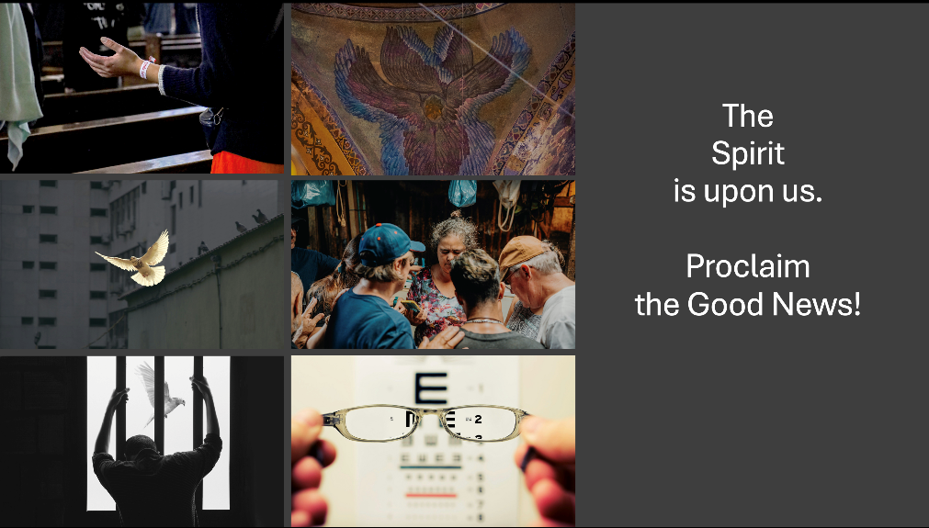

Fifth Sunday after Epiphany | February 9th, 2025

*Please stand as you are able

**Welcome and Announcements**

Trinity Chimes

**Prelude**  *To God Be the Glory* arr. L. Lamb

The Christ Church Ringers

*Call to Worship

One**:** I will change your name**.**

**Women: From Fearful to Risk Taker,**

**Men: From Judgmental to Loving-Kindness,**

**Women: From Brokenhearted to Being Healed,**

**Men: From Bitter to Joy-filled,**

**Women: From Left Behind to Draw the Circle Wider.**

One: God will be with you in every anxious moment, In tearful times, in times you would like to return to former ways.

**All: Thank God for His constant love.**

**Let us praise the name of the Lord**!

*Hymn of Praise 100 *God, Whose Love Is Reigning o'er Us* LAUDA ANIMA

1. God, whose love is reigning o'er us,

source of all, the ending true; hear the universal chorus raised in joyful praise to you:

Alleluia, Alleluia, worship ancient, worship new.

2. Word of God from nature bringing

springtime green and autumn gold;

mountain streams like children singing,

ocean waves like thunder bold:

Alleluia, Alleluia, as creation's tale is told.

3. Holy God of ancient glory, choosing man and woman, too:

Abr'am's faith and Sarah's story

formed a people bound to you.

Alleluia, Alleluia, to your covenant keep us true.

4. Covenant, new again in Jesus,

Star-child born to set us free;

sent to heal us, sent to teach us

how love's children we might be.

Alleluia, Alleluia, risen Christ, our Savior he!

5. Lift we then our human voices

in the songs that faith would bring;

live we then in human choices lives that, like our music sing:

Alleluia, Alleluia, joined in love our praises ring!

Opening Prayer

**O God, we your humble children ask your blessing on us. We adore you, whose name is love, whose nature is compassion, whose presence is joy, whose Word is truth, whose Spirit is goodness, whose holiness is beauty, whose will is peace, whose service is perfect freedom, and in knowledge of whom stands our eternal life. Unto you be all honor and all glory; through Jesus Christ our Lord. Amen.**

Scripture Reading Psalm 138

I give you thanks, O Lord,[[a](https://www.biblegateway.com/passage/?search=Psalms%20138&version=NRSVUE#fen-NRSVUE-16233a)] with my whole heart; before the gods I sing your praise;  
**I bow down toward your holy temple  
    and give thanks to your name for your steadfast**

**love and your faithfulness,**  
    for you have exalted your name

and your word above everything.   
**On the day I called, you answered me,  
    you increased my strength, my life.**

All the rulers of the earth shall praise you, O Lord,  
**for they have heard the words of your mouth.**  
and they shall sing of the ways of the Lord,  
**for great is the glory of the Lord.**  
For the Lord is high, he regards the lowly,  
    yet know the haughty from afar.

Though I walk in the midst of trouble,  
    you preserve my life;  
**you stretch out your hand against the wrath of my enemies  
    and your right hand delivers me.**  
**O Lord may your steadfast love, endure for ever.  
    Do not forsake the work of your hands.**

Music of Preparation *Heaven Bound*

K. Stewart

The Christ Church Ringers

**Scripture Reading Luke 5:1-11**

Sermon Being Caught! Don Finch

Musical Response

Prayers of the People

Prayer of Confession

**O God of signs and wonders, miracles and mighty deeds,**

**your healing and comfort reach into the messiness of our lives reminding us of your eternal presence. We confess that while you are a God of inclusion and healing, we are often a people of exclusion and brokenness. Send us your anointing and fresh insight for spiritual awakenings, and grant us your vision so that we might truly see your work, your people, your world, and participate as your Son Christ**

**calls us to participate, in the healing of all things. Amen.**

Pastor: Hear the Good News, Christ is among us renewing us for life with love. In the name of Christ, you are forgiven!

People: In the name of Christ you are forgiven!

All: Glory to God, Amen.

Lord’s Prayer

Our Father, who art in heaven, hallowed be thy name. Thy kingdom come, thy will be done, on earth as it is in heaven. Give us this day our daily bread and forgive us our trespasses as we forgive those who trespass against us, and lead us not into temptation, but deliver us from evil, for thine is the kingdom and the power and the glory forever. Amen.

*Passing of the Peace

Invitation to Offering

Offertory *Sonata of Love with Tchaikovsky's Piano Concert o No. 1* arr. Wrytzen

Kathy Ferguson, piano

*Doxology LASST UNS EFREUEUN

Praise God, from whom all blessings flow;

Praise God, all creatures here below.

Alleluia! Alleluia!

Praise God, the source of all our gifts!

Praise Jesus Christ, whose power uplifts!

Praise the Spirit, Holy Spirit,

Alleluia! Alleluia! Alleluia!

Offertory Prayer

**\*Sending Hymn** 2130 The Summons

KELVINGROVE

1. Will you come and follow me if I but call your name?

Will you go where you don't know and never be the same?

Will you let my love be shown,

will you let my name be known,

will you let my life be grown in you and you in me?

2. Will you leave yourself behind if I but call your name?

Will you care for cruel and kind and never be the same?

Will you risk the hostile stare?

should your life attract or scare?

Will you let me answer prayer in you and you in me?

3. Will you let the blinded see if I but call your name?

Will you set the prisoners free and never be the same?

Will you kiss the leper clean,

and do such as this unseen,

and admit to what I mean in you and you in me?

4. Will you love the "you" you hide if I but call your name?

Will you quell the fear inside and never be the same?

Will you use the faith you've found

to reshape the world around,

through my sight and touch and sound in you and you in me?

5. Lord, your summons echoes true

when you but call my name.

Let me turn and follow you and never be the same.

In your company I'll go

where your love and footsteps show.

Thus I'll move and live and grow in you and you in me.

Benediction

May the Lord bless you and keep you. May the Lord make his face to shine upon you and be gracious unto you. May the Lord lift up his countenance upon you and give you peace, Amen!

Postlude *Trumpet Voluntary*

Jeremiah Clarke

Thank you to all of the volunteers and staff who made this service possible!

Liturgist: Dot Waugaman

Guest Pastor: Don Finch

Stephen Minister: Carol Swango

Golf Cart Drive: Roger Erikson

ONE LICENSE A-738133 | CCLI #12393 | Perform Music #662 | CVLI #03793174

“God, Whose Love is Reigning o’er Us”

Words: William Boyd Grove, 1980

“The Summons”

Words: John Bell

If you have any questions, please call the office: 520.327.1116 or send us an e-mail: office@ccumtucson.org.

Staff contact information (Only staff with church emails are listed)

John Neve - Bell Choir Director

[john@ccumtucson.org](mailto:john@ccumtucson.org)

Janet Tolman – Organist

janet@ccumtucson.org

Sinamar Respicio – Choir Director

[choir@ccumtucson.org](mailto:choir@ccumtucson.org)

Mary Beth Buttler – Communications

communications@ccumtucson.org

Candi Eppley – Office Administrator

[office@ccumtucson.org](mailto:office@ccumtucson.org)

Rev. Beth Rambikur

[pastor@ccumtucson.org](mailto:pastor@ccumtucson.org)