### Large Print

### Christ Church United Methodisthttp://spartafumc.org/clientimages/45879/methodist%20cross.jpg

Connect with us online at

[www.ccumtucson.org](http://www.ccumtucson.org) [www.facebook/CCUM.Tucson](http://www.facebook/CCUM.Tucson)

­­­ 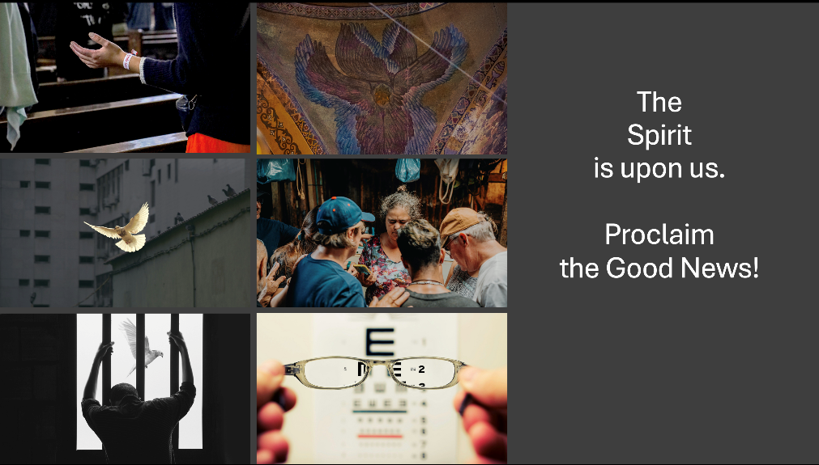

Third Sunday after Epiphany | January 26th, 2025

*Please stand as you are able

**Welcome and Announcements**

Trinity Chimes

**Prelude**  *This Is My Father's World/He's Got the Whole World in His Hands*

arr. Brant Adams

Cory Walavich, trombone

*Call to Worship

Pour out, Holy Spirit, pour out!

**On your people gathered here today,**

On our gifts of life and love.

**Anoint us to share the good news.**

To proclaim release and recovery.

**To celebrate the coming of the Lord’s favor.**

Fill us with courage, renew our calling,

**To share your wonder-working power with all the world.**

*Hymn of Praise 568 *Christ for the World We Sing* ITALIAN HYMN

1. Christ for the world we sing,

the world to Christ we bring,

with loving zeal; the poor,

and them that mourn,

the faint and over borne,

sin sick and sorrow worn,

whom Christ doth heal.

2. Christ for the world we sing,

the world to Christ we bring,

with fervent prayer;

the wayward and the lost,

by restless passions tossed,

redeemed at countless cost,

from dark despair.

3. Christ for the world we sing,

the world to Christ we bring,

with one accord; with us the work to share, with us reproach to dare,

with us the cross to bear,

for Christ our Lord,

4. Christ for the world we sing,

the world to Christ we bring,

with joyful song;

the newborn souls, whose days,

reclaimed from error's ways,

inspired with hope and praise,

to Christ belong.

Opening Prayer

**Gracious God, move among us today. Open our hearts to receive your good news. Give us courage to answer your call, and hope to proclaim your love in the world. In the name of Christ, we pray. Amen.**

**Scripture Reading** Psalm 19

The heavens are telling the glory of God,  
    and the firmament proclaims his handiwork.  
**Day to day pours forth speech,  
    and night to night declares knowledge.**  
There is no speech, nor are there words;  
    their voice is not heard;  
**yet their voice goes out through all the earth and their words to the end of the world.**

In the heavens he has set a tent for the sun,  
which comes out like a bridegroom from his wedding canopy, and like a strong man runs its course with joy.  
**Its rising is from the end of the heavens  
    and its circuit to the end of them,  
    and nothing is hid from its heat.**

The law of the Lord is perfect,  
    reviving the soul;  
**the decrees of the Lord are sure,  
    making wise the simple;**the precepts of the Lord are right,  
    rejoicing the heart;  
**the commandment of the Lord is clear,  
    enlightening the eyes;**the fear of the Lord is pure,  
    enduring forever;  
**the ordinances of the Lord are true  
    and righteous altogether.**More to be desired are they than gold,  
    even much fine gold;  
**sweeter also than honey  
    and drippings of the honeycomb.**

Moreover, by them is your servant warned;  
    in keeping them there is great reward.  
**But who can detect one’s own errors?  
    Clear me from hidden faults.**Keep back your servant also from the insolent; do not let them have dominion over me.  
**Then I shall be blameless  
    and innocent of great transgression.**

**Let the words of my mouth and the meditation of my heart  
    be acceptable to you,  
    O Lord, my rock and my redeemer.**

Music of Preparation *Spirit of God*

Dave and Jean Perry

The Chancel Choir

Scripture Reading Luke 4:14-21

Sermon The Power of the Spirit

Musical Response

Prayers of the People

Prayer of Confession

Word of Life, by the Holy Spirit, we are your new creation, sharing in the work of Christ to minister to the world.

Too often, we get lost in the bad news. We fail to see the poor, the captive, the blind, and the oppressed. But you come among us, calling us to renounce and reject the forces of wickedness, the evil powers of this world, and to repent of our sins. You offer us freedom and power to resist evil, injustice, and oppression in whatever forms they present themselves. Teach us to be a people of your mercy and grace, a refuge of love and healing, open to all people—regardless of age, nation, race, gender, ability, or economic condition.

Forgive us, renew us, and fill us with your Spirit, that we may live as signs of your hope in the world. In Christ’s name, we pray. Amen.

Pastor: Hear the Good News, Christ is among us renewing us for life with love. In the name of Christ, you are forgiven!

People: In the name of Christ you are forgiven!

All: Glory to God, Amen.

Lord’s Prayer

Our Father, who art in heaven, hallowed be thy name. Thy

kingdom come, thy will be done, on earth as it is in heaven. Give us this day our daily bread and forgive us our

trespasses as we forgive those who trespass against us, and lead

us not into temptation, but deliver us from evil, for thine is the

kingdom and the power and the glory forever. Amen.

*Passing of the Peace

Invitation to Offering

Offertory *Intermezzo Sinfonico*

Pietro Mascogni

Cory Walavich, trombone

*Doxology LASST UNS EFREUEUN

Praise God, from whom all blessings flow;

Praise God, all creatures here below.

Alleluia! Alleluia!

Praise God, the source of all our gifts!

Praise Jesus Christ, whose power uplifts!

Praise the Spirit, Holy Spirit,

Alleluia! Alleluia! Alleluia!

Offertory Prayer

**\*Sending Hymn** 2241 *The Spirit Sends Us Forth to Serve* LAND OF REST

1. The Spirit sends us forth to serve; we go in Jesus' name to bring glad tidings to the poor, God's favor to proclaim.

2. We go to comfort those who mourn and set the burdened free; where hope is dim, to share a dream and help the blind to see.

3. We go to be the hands of Christ, to scatter joy like seed and, all our days, to cherish life, to do the loving deed.

4. Then let us go to serve in peace, the gospel to proclaim. God's Spirit has empowered us; we go in Jesus' name.

Benediction

May the Lord bless you and keep you. May the Lord make his face to shine upon you and be gracious unto you. May the Lord lift up his countenance upon you and give you peace, Amen!

Postlude Psalm XIX Benedetto Marcello

Thank you to all of the volunteers and staff who made this service possible!

Liturgist: Susan Schreiner

Stephen Minister: Georgia Carmichael

Golf Cart Drive: Tobin Sidles

ONE LICENSE A-738133 | CCLI #12393 | Perform Music #662 | CVLI #03793174

“Christ for the World We Sing”

Words: Samuel Wolcott, 1869

“The Spirit Sends Us Forth to Serve”

Words: Delores Dufner, OSB

If you have any questions, please call the office: 520.327.1116 or

send us an e-mail: office@ccumtucson.org.

Staff contact information (Only staff with church emails are listed)

John Neve - Bell Choir Director

[john@ccumtucson.org](mailto:john@ccumtucson.org)

Janet Tolman – Organist

janet@ccumtucson.org

Sinamar Respicio – Choir Director

[choir@ccumtucson.org](mailto:choir@ccumtucson.org)

Mary Beth Buttler – Communications

communications@ccumtucson.org

Candi Eppley – Office Administrator

[office@ccumtucson.org](mailto:office@ccumtucson.org)

Rev. Beth Rambikur

[pastor@ccumtucson.org](mailto:pastor@ccumtucson.org)