### Large Print

### Christ Church United Methodisthttp://spartafumc.org/clientimages/45879/methodist%20cross.jpg

Connect with us online at

[www.ccumtucson.org](http://www.ccumtucson.org) [www.facebook/CCUM.Tucson](http://www.facebook/CCUM.Tucson)

­­­ 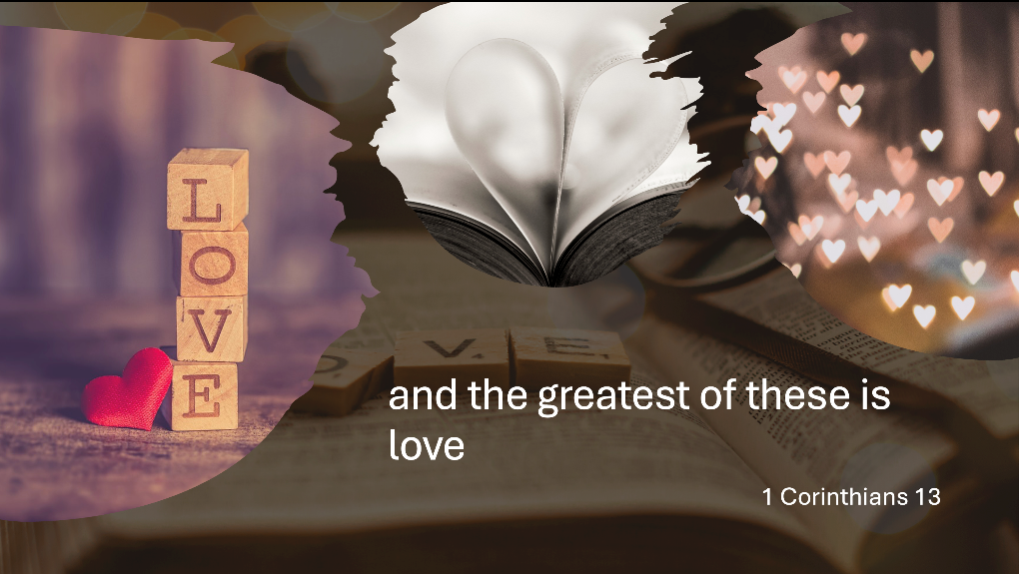

Third Sunday after Epiphany | January 19th, 2025

*Please stand as you are able

**Welcome and Announcements**

Trinity Chimes

**Prelude**  *Variations III & IV (from Variations on The Gift of Love)*

arr. Janet Linker

*Call to Worship

Give thanks to the Lord, for he is good,

**for his steadfast love endures forever.**

Give thanks to the God of gods,

**for his steadfast love endures forever.**

Give thanks to the Lord of lords,

**for his steadfast love endures forever.**

*Hymn of Praise 144 *This Is My Father's World* TERRA BEATA

1. This is my Father's world, and to my listening ears all nature sings, and round me rings the music of the spheres. This is my Father's world: I rest me in the thought

of rocks and trees, of skies and seas;

his hand the wonders wrought.

2. This is my Father's world, the birds their carols raise, the morning light, the lily white, declare their maker's praise.

This is my Father's world: he shines in all that's fair; in the rustling grass I hear him pass; he speaks to me everywhere.

3. This is my Father's world. O let me ne'er forget that though the wrong seems oft so strong, God is the ruler yet. This is my Father's world: why should my heart be sad? The Lord is King; let the heavens ring!

God reigns; let the earth be glad!

Opening Prayer

**Heavenly Father,**

**We come to worship today to hear your good news. To hear of faith, hope and love. We know that doubt, fear and hatred can shake even the strongest.**

**Shape us into faithful, hopeful people. Fill us with your love that passes all understanding. We pray this together in the name of Jesus Christ. Amen.**

**Scripture Reading** Psalm 62:5-12

For God alone my soul waits in silence,  
    for my hope is from God.  
**who alone is my rock and my salvation,  
    my fortress; I shall not be shaken.**On God rests my deliverance and my honor;  
    my mighty rock, my refuge is in God.

**Trust in God at all times, O people;  
    pour out your heart before;  
    God is a refuge for us. *Selah***

Those of low estate are but a breath;  
    those of high estate are a delusion;  
in the balances they go up; **they are together lighter than a breath.  
Put no confidence in extortion,  
    and set no vain hopes on robbery;**    if riches increase, do not set your heart on

them. Once God has spoken; twice have I

heard this:  
**that power belongs to God, and steadfast love belongs to you, O Lord.  
For you repay to all  
    according to their work.**

Music of Preparation *Here I am*

Allen Pote and Jack Schrader

The Chancel Choir

Scripture Reading 1 Corinthians 13: 1-13

Sermon Love, Love, Love

Musical Response

Prayers of the People

Prayer of Confession

Merciful God, we confess that we have sinned against you in thought, word, and deed, by what we have done and what we have left undone. We have not loved You with our whole heart; we have not loved our neighbors as ourselves. We justly deserve Your judgment. For our sake, and the sake of your son, Jesus Christ, have mercy on us. Forgive us, renew us, and lead us, so that we may delight in Your will and walk in Your ways that lead to glory. Amen.

Paula: Hear the Good News, Christ is among us renewing us for life with love. In the name of Christ, you are forgiven!

People: In the name of Christ you are forgiven!

All: Glory to God, Amen.

Lord’s Prayer

Our Father, who art in heaven, hallowed be thy name. Thy kingdom come, thy will be done, on earth as it is in heaven. Give us this day our daily bread and forgive us our trespasses as we forgive those who trespass against us, and lead us not into temptation, but deliver us from evil, for thine is the kingdom and the power and the glory forever. Amen.

*Passing of the Peace

Invitation to Offering

Offertory  *In This Very Room*

Ron and Carol Harris

Janet Waugaman and John Neve,

duet

*Doxology LASST UNS EFREUEUN

Praise God, from whom all blessings flow;

Praise God, all creatures here below.

Alleluia! Alleluia!

Praise God, the source of all our gifts!

Praise Jesus Christ, whose power uplifts!

Praise the Spirit, Holy Spirit,

Alleluia! Alleluia! Alleluia!

Offertory Prayer

**\*Sending Hymn** 2223 *They'll Know We Are Christians by Our Love*

ST. BRENDAN'S

1. We are one in the Spirit, we are one in the Lord, we are one in the Spirit, we are one in the Lord, and we pray that all unity may one day be restored:

**Refrain**

And they'll know we are Christians

by our love, by our love; yes, they'll know we are Christians by our love.

2. We will walk with each other,

we will walk hand in hand, we will walk with each other, we will walk hand in hand, and together we'll spread the news that God is in our land:

**Refrain**

3. We will work with each other, we will work side by side, we will work with each other, we will work side by side, and we'll guard human dignity and save human pride:

**Refrain**

4. All praise to the Father, from whom all things come, and all praise to Christ Jesus, God's only Son, and all praise to the Spirit, who makes us one:

**Refrain**

Benediction

May the Lord bless you and keep you. May the Lord make his face to shine upon you and be gracious unto you. May the Lord lift up his countenance upon you and give you peace, Amen!

Postlude *Joyful, Joyful, We Adore Thee* setting by Paul Manz

Thank you to all of the volunteers and staff who made this service possible!

Liturgist: Robert Stoebe

Guest Preacher: Paula Jameson

Stephen Minister: Robert Stoebe

Golf Cart Drive: Rick Aaberg

ONE LICENSE A-738133 | CCLI #12393 | Perform Music #662 | CVLI #03793174

“This Is My Father’s World”

Words: Maltbie D. Babgcock, 1901

“They’ll Know We Are Christians by Our Love”

Words: Peter Scholtes (John 13:34-35; Eph. 4:4-6)

If you have any questions, please call the office: 520.327.1116 or

send us an e-mail: office@ccumtucson.org.

Staff contact information (Only staff with church emails are listed)

John Neve - Bell Choir Director

[john@ccumtucson.org](mailto:john@ccumtucson.org)

Janet Tolman – Organist

janet@ccumtucson.org

Sinamar Respicio – Choir Director

[choir@ccumtucson.org](mailto:choir@ccumtucson.org)

Mary Beth Buttler – Communications

communications@ccumtucson.org

Candi Eppley – Office Administrator

[office@ccumtucson.org](mailto:office@ccumtucson.org)

Rev. Beth Rambikur

[pastor@ccumtucson.org](mailto:pastor@ccumtucson.org)

Notes