### Large Print

### Christ Church United Methodisthttp://spartafumc.org/clientimages/45879/methodist%20cross.jpg

Connect with us online at

[www.ccumtucson.org](http://www.ccumtucson.org) [www.facebook/CCUM.Tucson](http://www.facebook/CCUM.Tucson)

­­­ 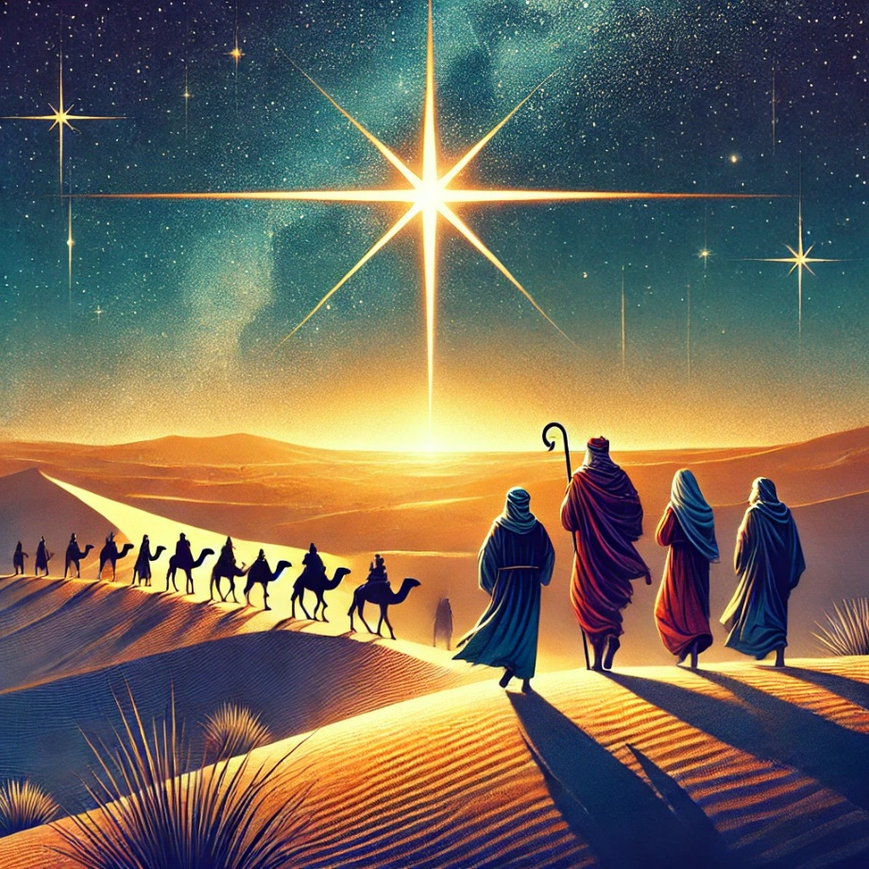

First Sunday after Epiphany | January 5th, 2025

*Please stand as you are able

**Welcome and Announcements**

Trinity Chimes

**Prelude** *Sing We Now of Christmas*

arr. Wilbur Held

*Call to Worship

One: Behold, a light shines in the darkness, piercing through the shadows,

All: And the darkness does not overcome it!

One: This light, Christ’s light, is the life of all people, filling us with awe and joy.

All: And so we come, worshiping with joy, as one people, following the light of Christ together, wherever it might lead.

*Hymn of Praise 237 *Sing We Now of Christmas*

FRENCH CAROL

1. Sing we now of Christmas, Noel, sing we here!

Hear our grateful praises to the babe so dear.

Refrain

Sing we Noel, the King is born, Noel!

Sing we now of Christmas, sing we now Noel!

2. Angels called to shepherds,

“Leave your flock at rest,

Journey forth to Bethlehem,

find the child so blest.

Refrain

3. In Bethlehem they found him;

Joseph and Mary mild,

seated by the manger,

watching the holy child.

Refrain

4. From the eastern country came the kings afar,

bearing gifts to Bethlehem, guided by a star.

Refrain

5. Gold and myrrh they took there,

gifts of greatest price;

There was never a stable so like paradise.

Refrain

Opening Prayer

**All: God who calls to us with dreams and visions, with signs and wonders; Your ways are not the ways of this world. Teach us to open our eyes, our ears, our hearts, and our lives to the grace and compassion you offer, lead us in Your way. Amen.**

**Scripture Reading** Isaiah 60:1-6

Arise, shine, for your light has come,

and the glory of the Lord has been upon you.

**“For darkness shall cover the earth**

**and thick darkness the peoples,**

but the Lord will arise upon you,

and his glory will appear over you.

**Nations shall come to your light**

**and kings to the brightness of your dawn.**

Lift up your eyes and look around;

they all gather together; they come to you; **your sons shall come from far away.**

**and your daughters shall be carried in their nurses’ arms.**

Then you shall see and be radiant;

your heart shall thrill and rejoice,

**because the abundance of the sea shall be**

**brought to you; the wealth of the nations**

**shall come to you.**

A multitude of camels shall cover you,

the young camels of Midian and Ephah;

all those from Sheba shall come.

**They shall bring gold and frankincense**

**and shall proclaim the praise of the Lord.**

**Children’s Moment**

*All Children are invited to come up to the front, when we finish they are invited to Sunday School.*

Music of Preparation *O That I Had A Thousand Voices* arr. Jay Althouse

The Chancel Choir

Gospel Reading Matthew 2:1-12

Sermon “The Road Goes Ever On and On”

Music of Response

*Passing of the Peace

Invitation to Offering

Offertory *He Is Born, the Holy Child*

arr. David Paxton

*Doxology LASST UNS EFREUN

Praise God, from whom all blessings flow;

Praise God, all creatures here below.

Alleluia! Alleluia!

Praise God, the source of all our gifts!

Praise Jesus Christ, whose power uplifts!

Praise the Spirit, Holy Spirit,

Alleluia! Alleluia! Alleluia!

Offertory Prayer

**\*Holy Communion**

The Lord be with you.

**And also with you.**

Lift up your hearts.

**We lift them up to the Lord.**

Let us give thanks to the Lord our God.

**It is right to give our thanks and praise.**

It is right, and a good and joyful thing, always and everywhere to give thanks to you, Almighty God, Creator of heaven and earth.

At the beginning of time you brought forth light from the darkness and declared it good. This light has never ceased to shine, sustaining your creation and renewing your people through the ages. In the fullness of time, you sent your Light into the world to dwell among us so that the darkness would never overcome your people. Your angels, filling the sleeping world with light, declared to the shepherds the birth of Immanuel, God with us. And guided by the light of your star wisemen found their way to the Christ Child.

Now, at the dawning of a new year, your light calls us to new beginnings so that we too might follow the light of Christ into all the world. Your glory breaks into our world, showing us the way of peace, justice, and love. So, with all your people on earth and the company of heaven, we praise your name and join their unending hymn:

**Holy, holy, holy Lord, God of power and might, heaven and earth are full of your glory. Hosanna in the highest. Blessed is the one who comes in the name of the Lord. Hosanna in the highest.**

Holy are you, and blessed is your Son, Jesus Christ.

In the fullness of time, you sent him, the light of the world, to dwell among us. Born in humility, he revealed your glory and proclaimed the good news of your kingdom. Now as the start of this year let Christ transform our lives, calling us to walk in the light of faith and to shine as beacons of hope in a weary world.

On the night in which he gave himself up for us, he took bread, gave thanks to you, broke the bread, gave it to his disciples, and said:

“Take, eat; this is my body, which is given for you. Do this in remembrance of me.” When the supper was over, he took the cup, gave thanks to you, gave it to his disciples, and said:

“Drink from this, all of you; this is my cup of the new covenant, poured out for you and for all for the forgiveness of sins. Do this, as often as you drink it, in remembrance of me.”

And so, in remembrance of these mighty acts in Jesus Christ, we offer ourselves in praise and thanksgiving as a holy and living sacrifice, in union with Christ’s offering for us, as we proclaim

the mystery of faith:

**Christ has died; Christ is risen; Christ will come again.**

Pour out your Holy Spirit on us gathered here, and on these gifts of bread and cup. Make them be for us the body and blood of Christ, that we may be for the world the body of Christ, redeemed

by his life.

By your Spirit, make us one with Christ, one with each other, and one in ministry to all the world, shining your light of love until Christ comes in final victory and we feast at his heavenly banquet.

**Through your Son Jesus Christ, with the Holy Spirit in your holy Church, all honor and glory is yours, Almighty God, now and forever.**

**Amen.**

**Communion Hymn** 186 *Alleluia*

ALLELUIA

1. Alleluia, alleluia, alleluia, alleluia,

alleluia, alleluia, alleluia, alleluia.

2.He's my Savior, alleluia, he's my Savior, alleluia,

He's my Savior, alleluia, he's my Savior, alleluia.

3. I will praise Him, alleluia, I will praise Him, alleluia,

I will praise Him, alleluia, I will praise Him, alleluia.

The Lord’s Prayer:

Our Father, who art in heaven, hallowed be thy name. Thy kingdom come, thy will be done, on earth as it is in heaven. Give us this day our daily bread and forgive us our trespasses as we forgive those who trespass against us, and lead us not into temptation, but deliver us from evil, for thine is the kingdom and the power and the glory forever. Amen

**\*Sending Hymn** 254 *We Three Kings*

KINGS OF ORIENT

1. We three kings of Orient are,

bearing gifts we traverse afar,

field and fountain, moor and mountain,

following yonder star.

**Refrain**

O star of wonder, star of light;

star with royal beauty bright,

westward leading, still proceeding,

guide us to thy perfect light.

2. Born a King on Bethlehem's plain,

gold I bring to crown him again,

King forever, ceasing never,

over us all to reign.

**Refrain**

3. Frankincense to offer have I;

incense owns a Deity nigh;

prayer and praising, voices raising,

worshiping God on high.

**Refrain**

4. Myrrh is mine; its bitter perfume

breathes a life of gathering gloom;

sorrowing, sighing, bleeding, dying,

sealed in the stone-cold tomb.

**Refrain**

5. Glorious now behold him arise;

King and God and sacrifice:

Alleluia, Alleluia,

sounds from the earth and skies.

**Refrain**

Benediction

May the Lord bless you and keep you. May the Lord make his face to shine upon you and be gracious unto you. May the Lord lift up his countenance upon you and give you peace, Amen!

Postlude *A Joyous Acclamation* Lani Smith

Thank you to all of the volunteers and staff who made this service possible!

Liturgist: Robert Stoebe

Stephen Minister: Gretchen Lofgren

Golf Cart Drive: Ron Thompson

ONE LICENSE A-738133 | CCLI #12393 | Perform Music #662 | CVLI #03793174

“Sing We Now of Christmas”

Words: Trad. French carol (Lk. 2:8-20; Mt. 2:1-12)

“Alleluia”

Words: Jerry Sinclair, 1972

“We Three Kings”

Words: John H. Hopkins, Jr. 1857 (Mt. 2:1-12)

If you have any questions, please call the office: 520.327.1116 or

send us an e-mail: office@ccumtucson.org.

Staff contact information (Only staff with church emails are listed)

John Neve - Bell Choir Director

[john@ccumtucson.org](mailto:john@ccumtucson.org)

Janet Tolman – Organist

janet@ccumtucson.org

Sinamar Respicio – Choir Director

[choir@ccumtucson.org](mailto:choir@ccumtucson.org)

Mary Beth Buttler – Communications

communications@ccumtucson.org

Candi Eppley – Office Administrator

[office@ccumtucson.org](mailto:office@ccumtucson.org)

Rev. Beth Rambikur

[pastor@ccumtucson.org](mailto:pastor@ccumtucson.org)