LARGE PRINT
Christ Church United Methodist
Connect with us online at
www.ccumtucson.org www.facebook/CCUM.Tucson

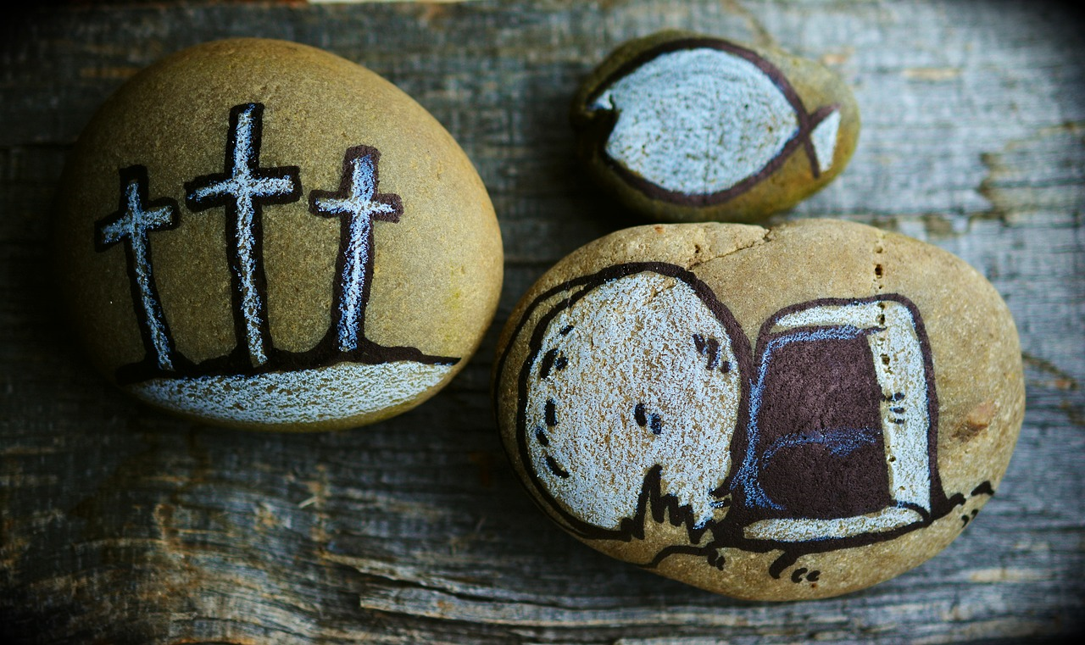

First Sunday of Easter, April 7th, 2024

Welcome and Announcements

*Please stand

Trinity Chimes

Prelude Because He Lives arr. Whitworth
Kathy Ferguson, piano;
Janet Tolman, organ

*Call to Worship UMH 6

One: The grace of the Lord Jesus Christ be with you.

All: And also with you.

One: The risen Christ is with us.

All: Praise the Lord!

*Hymn of Praise 304 Easter People, Raise Your Voices

REGENT SQUARE

1. Easter people, raise your voices, sounds of heaven in earth should ring. Christ has brought us heaven’s choices; heavenly music, let it ring. Alleluia! Alleluia! Easter people, let us sing.

2. Fear of death can no more stop us from our pressing here below. For our Lord empowered us to triumph over every foe. Alleluia! Alleluia! On to victory now we go.

3. Every day to us is Easter, with its resurrection song. When in trouble move the faster to our God who rights the wrong. Alleluia! Alleluia! See the power of heavenly throngs.

Opening Prayer

God of abundance, we are thankful for the beauty all around us. Weave us together in a life full of goodness and joy. Help us to move in harmony with one another and with all Creation. Let us travel on your path toward release in your presence. Amen.

Written by Rev. Laurie Bayen and Rev. Laura Baumgartner

Responsive Reading Psalm 133: 1-3
Behold, how good and pleasant it is
When we live together in unity!
It is like the precious oil upon the head,
running down upon the beard,
upon the beard of Aaron,
Running down on the collar of his robes!
It is like the dew of Hermon
Which falls on the mountains of Zion!
For there the Lord has commanded the blessing,
life for evermore.

Music of Preparation We Will Glorify

Twila Paris and Jack Schrader

The Chancel Choir

Scripture Reading Acts 4:32-35

Sermon One perfect moment

Musical Response

*The Passing of the Peace

Invitation to Offering

Offertory I Cannot Tell Camp Kirkland

Sinamar Respicio, solo

*Doxology 94 Praise God, from Whom all Blessings Flow

Praise God, from whom all blessings flow;

Praise God, all creatures here be low: Alleluia! Alleluia!

Praise God, the source of all our gifts!

Praise Jesus Christ, whose power up lifts!

Praise the Spirit, Holy Spirit!

Alleluia! Alleluia! Alleluia!

*Offertory Prayer

*Communion

The Lord be with you

And Also with you!

Lift up your hearts.

We lift them up to the Lord.

Let us give thanks to the Lord our God.

It is right to give our thanks and praise.

It is right, and a good and joyful thing,
always and everywhere to give thanks to you,
Almighty God, creator of heaven and earth.
You shaped us from the dust of the earth and breathed life into us, forming humanity in your image.
And so, with your people on earth and all the company of heaven we praise your name and join their unending hymn:

Holy, holy, holy Lord, God of power and might,
Heaven and earth are full of your glory. Hosanna in the highest. Blessed is he who comes in the name of the Lord. Hosanna in the highest.

Holy are you, and blessed is your Son Jesus Christ. By the baptism of his suffering, death, and resurrection you gave birth to your Church, delivered us from our slavery to sin and death, and made with us a new covenant by water and the Spirit.

On the night in which he gave himself up for us, he took bread, gave thanks to you, broke the bread, gave it to his disciples, and said: "Take, eat; this is my body which is given for you. Do this in remembrance of me."

When the supper was over he took the cup,
gave thanks to you, gave it to his disciples, and said: "Drink from this, all of you; this is the new covenant, poured out for you and for all for the forgiveness of sins.
Do this, as often as you drink it, in remembrance of me."

And so, in remembrance of these your mighty acts in Jesus Christ, we offer ourselves in praise and thanksgiving as a holy and living sacrifice, in union with Christ's offering for us, as we proclaim the mystery of faith.

Christ has died; Christ is risen; Christ will come again.

Pour out your Holy Spirit on us gathered together, and on these gifts of food and drink. Make them be for us the body and blood of Christ, that we may be for the world the body of Christ, redeemed by his love.

By your Spirit make us one with Christ, one with each other, and one in ministry to all the world until Christ comes in final victory, and we feast at his heavenly banquet.

Through your Son Jesus Christ, with the Holy Spirit in your holy Church, all honor and glory is yours, almighty Father (God), now and forever. Amen!

*Communion Hymn 632 Draw Us in the Spirit's Tether UNION SEMINARY

1. Draw us in the Spirit’s tether, for when humbly

In thy name, two or three are met together,

thou art in the midst of them. Alleluia!

Alleluia! Touch we now thy garment’s hem.

2. As disciples used to gather in the name of

Christ to sup, then with thanks to God the

Father break the bread and bless the cup:

Alleluia! Alleluia! So now bind our

friendship up.

3. All our meals and all our living make as sacraments of thee, That by caring, helping, giving, we my true disciples be.

Alleluia! Alleluia! We will serve thee faithfully.

Lord’s Prayer

Our Father, who art in heaven, hallowed be thy name.

Thy kingdom come, thy will be done, on earth as it is in heaven. Give us this day our daily bread and forgive us our trespasses as we forgive those who trespass against us, and lead us not into temptation, but ieliver us from evil, for thine is the kingdom and the power and the glory forever. Amen.

*Closing Hymn 547 O Church of God, United ELLACOMBE

1. O church of God, united to serve one

common Lord, proclaim to all one message, with hearts in glad accord. Christ ever goes before us; we follow day by day with strong and eager foot steps along the upward way.

2. From every land and nation the ordered

ranks appear; to serve one valiant leader they

come from far and near. They chant their one

confession, they praise one living Lord, and

place their sure dependence upon his saving

word.

3.Though creeds and tongues may differ they speak, O Christ of thee; and in thy loving spirit we Shall one, people be. Lord, may our faithful

service and singleness of aim proclaim to all

the power of thy redeeming name.

4. May thy great prayer be answered that we may

all be one, close bound, by love united in

thee, God’s blessed Son: to bring a single

witness, to make the pathway bright, that

souls which grope in darkness may find the one

true light.

*Benediction

The grace of the Lord Jesus Christ, and the love of God, And the fellowship of the Holy Spirit be with you all. Amen.

Postlude Toccata No.9 (DIADEMATA)

arr. Joel Raney

ONE LICENSE A-738133 | CCLI #12393 | Perform Music #662 | CVLI #03793174

“Easter People, Raise Your Voices”

Words: William M James, 1979

“Draw Us in the Spirit’s Tether”

Words: Percy Dearmer, 1931 (Mt. 18:20)

“O Church of God, United“

Words: Frederick B Morley, 1953 (Acts 2:5-11)

Liturgist: Dot Waugaman

Stephen Minister: Cat Reinke

Thank you to all the staff and volunteers who made this service possible!

If you have any questions, please call the office: 520.327.1116 or

send us an e-mail: office@ccumtucson.org.

Staff contact information (Only staff with church emails are listed)

John Neve - Bell Choir Director

john@ccumtucson.org

Janet Tolman – Organist

janet@ccumtucson.org

Sinamar Respicio – Choir Director

choir@ccumtucson.org

Mary Beth Buttler – Communications

communications@ccumtucson.org

Candi Eppley – Office Administrator

office@ccumtucson.org

Rev. Beth Rambikur

pastor@ccumtucson.org

NOTES

