Christ Church United Methodist
Connect with us online at
www.ccumtucson.org www.facebook/CCUM.Tucson
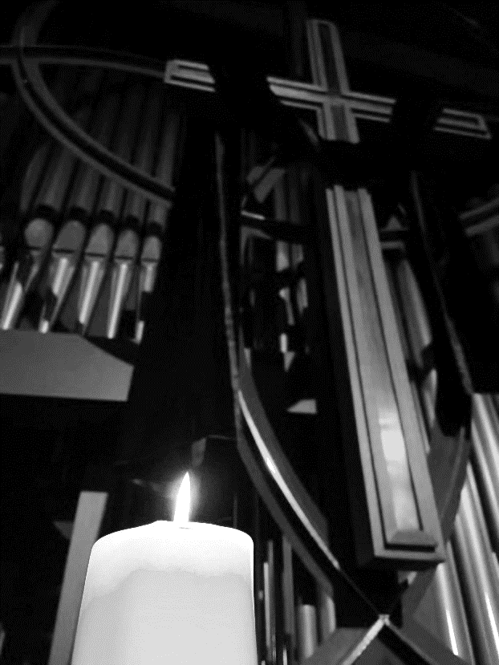

Blessed Is the Way – A Good Friday Journey
Friday, March 29, 2024

Prelude Lamb of God Joe Utterback

We invite you to gather and dismiss in silence please.

*Please stand

Words of Welcome

*Call to Worship
One: We begin – with silence
All: The silence of broken expectations.
One: The silence of betrayal.
All: The silence of wrongful accusations.
One: The silence of destruction.
All: There are times when songs falter,
One: When prayers fall quiet.
All: When words cannot reach beyond the edges of loss.
One: In those times there is – silence
All: Let us be in the silence and know, know beyond a shadow of a doubt that God, You are here.

*Opening Hymn 298 When I Survey the Wonderous Cross
ROCKINGHAM LM
1. When I survey the wondrous cross
on which the Prince of Glory died;
my richest gain I count but loss,
and pour contempt on all my pride.
2. Forbid it, Lord, that I should boast,
save in the death of Christ, my God;
all the vain things that charm me most,
I sacrifice them to his blood.
3. See, from his head, his hands, his feet,
sorrow and love flow mingled down.
Did e'er such love and sorrow meet,
or thorns compose so rich a crown.
4. Were the whole realm of nature mine,
that were an offering far too small;
love so amazing, so divine,
demands my soul, my life, my all.

Opening Prayer
We believe in God, God who is love and compassion. We believe in the sun, in its light and warmth and power, even when it is not shining. We believe in love, love that transforms, love that forgives, love that shakes the world’s foundations, even when we do not feel it. We believe in God, even when God is silent.

1st Blessing – To Be Light

You are the light of the world. A city built on a hill cannot be hid. No one after lighting a lamp puts it under the bushel basket, but on the lampstand, and it gives light to all in the house. In the same way, let your light shine before others, so that they may see your good works and give glory to your Father in heaven.

Matthew 26:47-50, 55-56

1st Reflection

Extinguishing the first candle

Hymn 2129 I have decided to follow Jesus ASSAM

I have decided to Follow Jesus,

I have decided to follow Jesus,

I have decided to follow Jesus,

no turning back, no turning back.

2nd Blessing – To Be Salt
You are the salt of the earth; but if salt has lost its taste, how can its saltiness be restored? It is no longer good for anything but it is thrown out and trampled underfoot.

Mark 14:53-65

2nd Reflection

Extinguishing the second candle

Hymn 294 Alas! And Did my Savior Bleed

1. Alas! and did my Savior bleed,
and did my Sovereign die?
Would he devote that sacred head
for sinners such as I?
2. Was it for crimes that I have done,
he groaned upon the tree?
Amazing pity! Grace unknown!
And love beyond degree!

5. But drops of tears can ne'er repay
the debt of love I owe.
Here, Lord, I give myself away;
'tis all that I can do.

3rd Blessing – To Be Reviled

Blessed are you when people revile you and persecute you and utter all kinds of evil against you falsely on my account. Rejoice and be glad, for your reward is great in heaven, for in the same way they persecuted the prophets who were before you.

Mark 14:66-72

3rd Reflection

Extinguishing the third candle

Hymn 2130 The Summons KELVINGROVE

Will you come and follow me if I but call your name?

Will you go where you don’t know and never be the same?

Will you let my love be shown, will you let my name be known?

Will you let my life be grown in you and you in me?

4th Blessing – To Listen to Your Heart

Blessed are the pure in heart, for they will see God.

Mark 15:1-5

4th Reflection

Extinguishing the fourth candle

Special Music Lamb of God,
What Wondrous Love Faure/Petker
Paula Jameson, solo

5th Blessing – To Be Persecuted

Mark 15:6-15

Blessed are those who are persecuted for righteousness sake, for theirs is the kingdom of heaven.

5th Reflection

Extinguishing the fifth candle

Hymn 289 Ah, Holy Jesus HERZLIEBSTER JESU

1. Ah, holy Jesus, how hast thou offended,
that we to judge thee have in hate pretended?
By foes derided, by thine own rejected,
O most afflicted!
2. Who was the guilty? Who brought this upon thee?
Alas, my treason, Jesus, hath undone thee!
'Twas I, Lord Jesus, I it was denied thee;
I crucified thee.

6th Blessing – To Be Merciful

Mark 15:16-20

Blessed are the merciful, for they will receive mercy

6th Reflection

Extinguishing the sixth candle

Special Music How Deep the Father’s Love for Us

Arr. Mark Hayes

Chancel Choir, Charlotte Bond, cello

7th Blessing – To Be Meek

Mark 15:21-24
Blessed are the meek, for they will inherit the earth

7th Reflection

Extinguishing the seventh candle

Hymn – 288 Where you There WERE YOU THERE

1 Were you there when they crucified my Lord? (were you there)Were you there when they crucified my Lord? (were you there) Oh! sometimes it causes me to tremble, tremble, tremble. Were you there when they crucified my Lord? (were you there)

8th Blessing – To Be Peacemakers

Mark 15:25-32

Blessed are the peacemakers, for they will be called children of God.

8th Reflection

Extinguishing the eighth candle

Hymn 292 What Wondrous Love Is This

WONDEROUS LOVE

1. What wondrous love is this, O my soul, O my soul,
what wondrous love is this, O my soul!
What wondrous love is this that caused the Lord of bliss
to bear the dreadful curse for my soul, for my soul,
to bear the dreadful curse for my soul.

9th Blessing – O Death where is your Victory?

Mark 15:33-37

Blessed are those who hunger and thirst for righteousness, for they will be filled.

Silent Reflection

Extinguishing the ninth candle

Special Music Rise Again Dallas Holm Tom Messmore, solo

10th Blessing – To Shake the Foundations of the World

Blessed are the poor in spirit, for theirs is the kingdom of heaven.

Mark 15:38-39

10th Reflection

Extinguishing the tenth candle

Hymn 168 At the Name of Jesus KING’S WESTON

2. Humbled for a season, to receive a name
from the lips of sinners unto whom he came,
faithfully He bore it, spotless to the last,
brought it back victorious when from death he passed.

11th Blessing – The rock on which hope is built

Blessed are those who mourn, for they will be comforted.

Mark 15:40-47

11th reflection

Extinguishing the final candle

Hymn Silent Night

Silent night, holy night, Christ has died, gone from sight, laid to rest is Christ our King, in the tomb will silence ring, waiting for God’s holy work, waiting for God’s holy work.

Silent night, holy night, Son of God, love’s pure light; radiant beams from thy holy face with the dawn of redeeming grace, Jesus, Lord, at thy death, Jesus, Lord, at thy death.

Silent night, holy night, soldiers quake at the sight; glories stream from heaven above, rocks cannot hold God’s full love, Christ will rise in the dawn, Christ will rise in the dawn

Final Reflection – Lighting the First Candle

Benediction

May God whose love persists abide with us. May Christ who teaches love keep our hearts in hope, and may the Holy Spirit stir our souls with the promise of the dawn, for joy comes in the morning. Amen.

Postlude O Sacred Head arr. Don Hustad

Please exit in silence

ONE LICENSE A-738133 | CCLI #12393 | PerformMusic #662 | CVLI #03793174

“When I Survey the Wondrous Cross”

Words: Isaac Watts, 1707 (Gal. 6:14)

“I Have Decided to Follow Jesus

Words: Anon.

“Alas! And Did My Savior Bleed

Words: Isaac Watts, 1707

“The Summons”

Words: John Bell

“Ah, Holy Jesus

Words: Johann Heermann, 1630; trans by Robert S Bridges, 1899

“Were You There”

Words: Afro-American Spiritual

“What Wondrous Love Is This”

Words: USA Folk Hymn

“At the Name of Jesus”

Words: Caroline M Noel, 1870 (Phil. 2;5-11)

Liturgists: Don Finch and John Neve

Thank you to all the staff and volunteers who made this service possible!

If you have any questions, please call the office: 520.327.1116 or

send us an e-mail: office@ccumtucson.org.

