Christ Church United Methodist
Connect with us online at
www.ccumtucson.org www.facebook/CCUM.Tucson

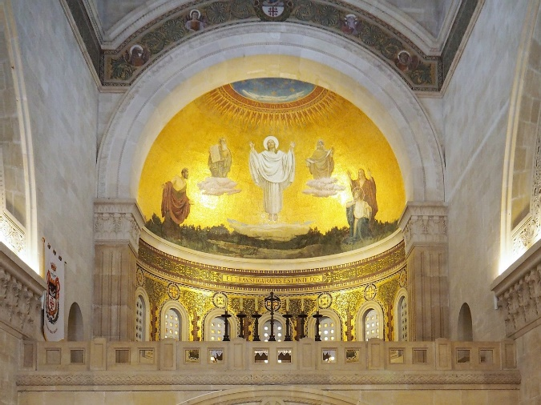

Transfiguration Sunday | February 11th, 2024

*Please stand as you are able

Welcome and Announcements

Trinity Chimes

Prelude Rondo Jubilee B. Austin
The Christ Church Ringers

*Call to Worship:
One: Behind the way things are
All: There is the reality of God whispering possibility.
One: Beyond the troubles that divide and destroy
All: There is the passion of love and hope.
One: Within the brokenness of life
All: There lives a hidden wholeness calling all and each to transformation.

*Hymn of Praise 188 Christ Is the World's Light

CHRISTE SANCTORUM

1. Christ is the world’s light, Christ and none other; born in our darkness, he became our brother. If we have seen him, we have seen the Father: Glory to God on high!

2. Christ is the world’s peace, Christ and none other; no one can serve him and despise another. Who else unites us, one in God the Father? Glory to God on high!

3. Christ is the world’s life, Christ and none other; sold once for silver, murdered here, our brother; he, who redeems us,

reigns with God the Father: Glory to God on high!

4. Give God the glory, God and none other; give God the glory, Spirit, Son and Father; give God the glory, God with us, my brother: Glory to God on high!

Opening Prayer
God of transformation, from a seed there comes a flower, from the darkness streams the light, reminding us in all things transformation is possible. Transfigure our hearts, our minds, and our lives so that we might be your disciples always and everywhere. Amen

Responsive Scripture Reading Psalm 50:1-6

The mighty one, God the Lord,
speaks and summons the earth
from the rising of the sun to its setting.
Out of Zion, the perfection of beauty,
God shines forth.
Our God comes and does not keep silent;
before him is a devouring fire
and a mighty tempest all around him.
He calls to the heavens above
and to the earth, that he may judge his people:
Gather to me my faithful ones,
who made a covenant with me by sacrifice!
The heavens declare his righteousness,
for God himself is judge.

Music of Preparation Just a Closer Walk

arr. V. Stephenson

The Christ Church Ringers

Gospel Lesson Mark 9:2-10

Sermon What We Keep: Transfiguration Sunday

Music of Response Open My Eyes

arr. Paul Taylor

Prayers of the People

Prayer of Confession
Transfiguring God, you call us to change, you summon us to revelation, you ask us to live in the deepest reality of this world, love. Yet we stay stuck, we turn from wonder, and we leave the messiness of love to others. Stay with us always as we share the risks and challenges of living our faith. By your powerful Spirit, turn our fear to courage. Open our hearts. Change our minds. Shine in our hearts and lives so that you may be praised in all we do. Amen.
Adapted from work written by Ruth C. Duck in Touch Holiness.

Pastor: Hear the Good News, Christ is among us renewing us for life with love. In the name of Christ, you are forgiven!

People: In the name of Christ you are forgiven!

All: Glory to God, Amen.

The Lord’s Prayer:

Our Father, who art in heaven, hallowed be thy name. Thy kingdom come, thy will be done, on earth as it is in heaven. Give us this day our daily bread and forgive us our trespasses as we forgive those who trespass against us, and lead us not into temptation, but deliver us from evil, for thine is the kingdom, the power, and the glory, forever, Amen.

*Passing of the Peace

Invitation to Offering

Offertory Holy Ground arr. Mark Hayes

*Doxology LASST UNS EFREUN

Praise God, from whom all blessings flow;

Praise God, all creatures here below.

Alleluia! Alleluia!

Praise God, the source of all our gifts!

Praise Jesus Christ, whose power uplifts!

Praise the Spirit, Holy Spirit,

Alleluia! Alleluia! Alleluia!

*Offertory Prayer

*Sending Hymn 2103 We Have Come at Christ's Own Bidding HYFRYDOL

1. We have come at Christ’s own bidding to this high and holy place, where we wait with

hope and longing for some token of God’s grace. Here we pray for new assurance that our faith is not in vain, searching like those first disciples for a sign both clear and plain.

2. Light breaks through our clouds and shadows, splendor bathes the flesh joined Word, Moses and Elijah marvel as the heavenly voice is heard.

Eyes and hearts behold with wonder how the Law and Prophets meet: Christ with garments drenched in brightness, stands transfigured and complete.

3. Strengthened by this glimpse of glory, fearful lest our faith decline, we, like Peter,

find it tempting to remain and build a shrine.

But true worship gives us courage to proclaim what we profess, that our daily lives may prove us people of the God we bless.

Benediction

May the Lord bless you and keep you. May the Lord make his face to shine upon you and be gracious unto you. May the Lord lift up his countenance upon you and give you peace, Amen!

Postlude Trumpet Tune Alejandro D. Consolacion II

Thank you to all of the volunteers and staff who made this service possible!

Liturgist: Lynda Turrentine

Stephen Minister: Susan Schreiner

ONE LICENSE A-738133 | CCLI #12393 | Perform Music #662 | CVLI #03793174

“Christ Is the World’s Light”

Words: Fred Pratt Green, 1968

“We Have Come at Christ’s Own Bidding”

Words: Carl P Daw, Jr. (Matt. 27:1-8,Mark 9:2-8

Luke :9:28-36)

If you have any questions, please call the office: 520.327.1116 or

send us an e-mail: office@ccumtucson.org

Staff contact information (Only staff with church emails are listed)

John Neve - Bell Choir Director

john@ccumtucson.org

Janet Tolman – Organist

janet@ccumtucson.org

Sinamar Respicio – Choir Director

choir@ccumtucson.org

Mary Beth Buttler – Communications

communications@ccumtucson.org

Candi Eppley – Office Administrator

office@ccumtucson.org

Rev. Beth Rambikur

pastor@ccumtucson.org

Notes

