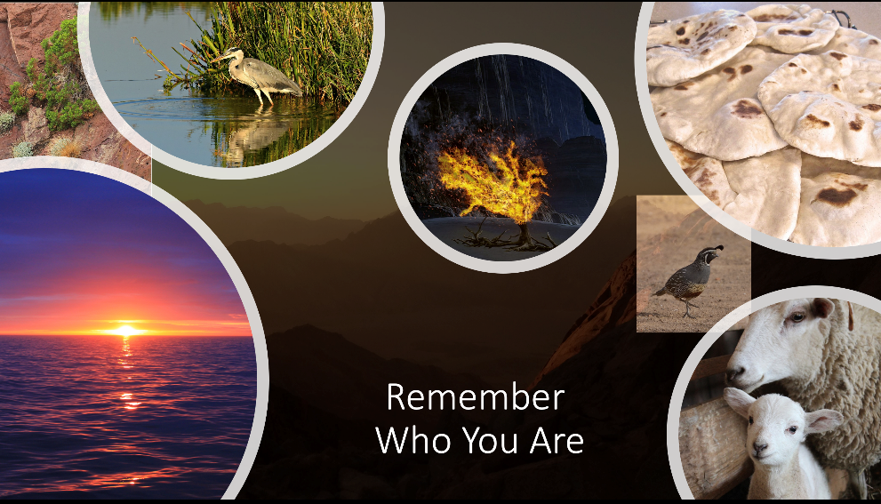
Eighteenth Sunday after Pentecost | October 1st, 2023

*Please stand
As you are able

Welcome and Announcements

Trinity Chimes

Prelude BRADBURY Variations Ivan Burnett, Jr.

*Call to Worship:
One: As a stream flows through a desert giving life,
All: So your Spirit pours into us renewing life.
One: Even when we quarrel with bitterness
All: You are among us inviting us to peace.

*Hymn of Praise 648 God the Spirit, Guide and Guardian
HYFRYDOL

1.God the Spirit, guide and guardian, wind-sped flame and
Hovering dove, breath of life and voice of prophets, sign
of blessing, power of love: give to those who lead your
People fresh anointing of your grace; send them forth as
bold apostles to your church in every place.

3. Great Creator, life bestower, truth beyond all
thought’s call, fount of wisdom, womb of mercy, giving
and forgiving all: as you know our strength and
Weakness, so may those the church exalts over see her
Life steadfastly yet not overlook her faults.

4. Triune God, mysterious being, undivided
And diverse, deeper than our minds can fathom, greater
Than our creeds rehearse: help us in our varied.
Callings your full image to proclaim, that our ministries
Uniting may give glory to your name.

Opening Prayer
Lord, open our hearts and minds as by the power of your Holy Spirit, that, as the Scriptures are read and your Word proclaimed, we may hear with joy what you say to us today. Amen
(UM Prayer for Illumination pg. 34 BOW)

Scripture Lesson Psalm 78:1-4, 12-16 (UMH 799)

Give ear, O my people, to my teaching:

incline your ears to the words of my mouth!

I will open my mouth in a parable;

I will utter dark sayings from the old,

things that we have heard and known,

that our forebears have told us.

We will not hide them from their children,

but tell to the coming generation

the glorious deeds of the Lord, the might,

and wonders God has wrought.

The Lord wrought marvels in the sight of their forebears

in the land of Egypt, in the fields of Zoan,

the Lord divided the sea and let them pass through it,

and made the waters stand like a heap,

led them with a cloud in the daytime,

And all the night with a fiery light,

cleft rocks in the wilderness,

and gave them drink abundantly as from the deep,

made streams come out of the rock,

and caused waters to flow down like rivers.

Children’s Moment

Music of Preparation Come to me Dan Forrest
Isabel Aurora Burgos-DeStephanis, cello
The Chancel Choir

Scripture Lesson Exodus 17:1-7

Sermon Thirsty

Musical Response

*Passing of the Peace

Invitation Offering

Offertory Gift of Finest Wheat setting by Charles Callahan

*Doxology 95 Praise God, from Whom all Blessings Flow

Praise God, from whom all blessings flow;

praise him, all creatures here below;

praise him above, ye heavenly host;

praise Father, Son, and Holy Ghost.

Amen.

*Offertory Prayer

Communion
The Lord be with you.
And also with you.
Lift up your hearts.
We lift them up to the Lord.
Let us give thanks to the Lord our God.
It is right to give our thanks and praise.

It is right, and a good and joyful thing,
always and everywhere to give thanks to you,
Almighty God, creator of heaven and earth.
You shaped us from the dust of the earth and breathed life
into us, forming humanity in your image.
By your mighty hand you saved your people from Egypt,
dividing the waters, providing food and water in the desert,
protecting your people so that none were lost.
And so, with your people on earth and all the company of
heaven we praise your name and join their unending hymn:

Holy, holy, holy Lord, God of power and might,
Heaven and earth are full of your glory. Hosanna in the
highest. Blessed is he who comes in the name of the
Lord. Hosanna in the highest.

Holy are you, and blessed is your Son Jesus Christ.
By the baptism of his suffering, death, and resurrection
you gave birth to your Church, delivered us from our
slavery to sin and death, and made with us a new covenant
by water and the Spirit.

On the night in which he gave himself up for us, he took
bread, gave thanks to you, broke the bread, gave it to his
disciples, and said: “Take, eat; this is my body which is
given for you. Do this in remembrance of me.”
When the supper was over he took the cup,
gave thanks to you, gave it to his disciples, and said:
“Drink from this, all of you; this is the new covenant,
poured out for you and for all for the forgiveness of sins.
Do this, as often as you drink it, in remembrance of me”

And so, in remembrance of these your mighty acts in Jesus
Christ, we offer ourselves in praise and thanksgiving as a
holy and living sacrifice, in union with Christ’s offering for
us, as we proclaim the mystery of faith.

Christ has died; Christ is risen; Christ will come again.

Pour out your Holy Spirit on us gathered here, and on these
gifts of food and drink. Make them be for us the body and
blood of Christ, that we may be for the world the body of
Christ, redeemed by his blood.

By your Spirit make us one with Christ,
one with each other, and one in ministry to all the
world, until Christ comes in final victory, and we feast
at his heavenly banquet. Through your Son Jesus
Christ, with the Holy Spirit in your holy Church, all
honor and glory is yours, almighty Father (God), now
and forever.
Amen

Communion Hymn 2126 All Who Hunger HOLY MANNA

1. All who hunger, gather gladly; holy manna

Is our bread. Come from wilderness and wandering.

Here, in truth, we will be fed. You that yearn for

Days of fullness, all around us is our food.

Taste and see the grace eternal. Taste and see that God

is good

2. All who hunger, never strangers; seeker, be a

Welcome guest. Come from restlessness and roaming.

Here, in joy we keep the feast. We that once were

Lost and scattered in communion’s love have stood.

Taste and see the grace eternal. Taste and see that God

is good

The Lord’s Prayer

Our Father, who art in heaven, hallowed be thy name.

Thy kingdom come, thy will be done, on earth as it is in heaven. Give us this day our daily bread and forgive us our trespasses as we forgive those who trespass against us, and lead us not into temptation, but deliver us from evil, for thine is the kingdom and the power and the glory forever. Amen

*Sending Hymn 130 God Will Take Care of You MARTIN

1. Be not dismayed whate'er betide,
God will take care of you;
beneath his wings of love abide,
God will take care of you.
Refrain:
God will take care of you,
through every day, o'er all the way;
he will take care of you,
God will take care of you.

3. All you may need he will provide,
God will take care of you;
nothing you ask will be denied,
God will take care of you.
(Refrain)
4. No matter what may be the test,
God will take care of you;
lean, weary one, upon his breast,
God will take care of you.
(Refrain)

*Benediction

Remember who you are, a child of God, known, named, loved, and called. Know that God - Source, Word, and Spirit - is our help from age to age. Go into the world to love and serve.

Postlude All Creatures of Our God and King arr. Ivan Burnett, Jr.

Liturgist: Bob Stoebe

Stephen Minister: Cat Reinke

Thank you to all of the volunteers and staff who made this service possible!

ONE LICENSE A-738133 | CCLI #12393 | Perform Music #662 | CVLI #03793174

“God the Spirit, Guide and Guardian”

Words: Carl P. Daw, Jr. 1987

“All Who Hunger”

Words: Sylvia G. Dunstan (Exod.16:13-15;Ps. 34:8;John 4:10 1 Cor. 5:8)

If you have any questions, please call the office: 520.327.1116 or

send us an e-mail: office@ccumtucson.org.

Our Staff contact information

John Neve - Bell Choir Director

john@ccumtucson.org

Janet Tolman – Organist

janet@ccumtucson.org

Sinamar Respicio – Choir Director

choir@ccumtucson.org

Mary Beth Buttler – Communications

communications@ccumtucson.org

Candi Eppley – Office Administrator

office@ccumtucson.org

Rev. Beth Rambikur

pastor@ccumtucson.org

