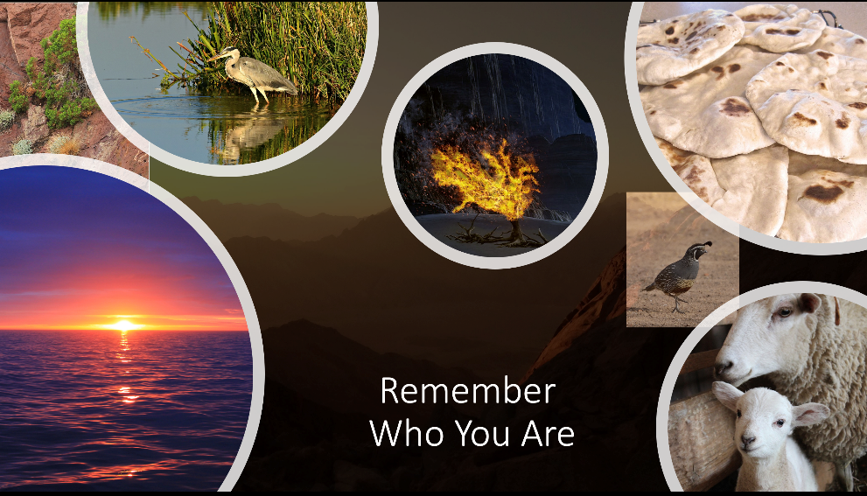

Fourteenth Sunday after Pentecost | September 3rd, 2023

*Please stand

As you are able

**Welcome and Announcements**

Trinity Chimes

**Prelude**  *Prelude* Cesar Franck

Kathryn Snodgrass, piano;

Janet Tolman, organ

**\*Call to Worship:**

One: Turn aside and see

**All: The wonder waiting for us to be**

One: Open to calls new and old

**All:  Where God's work will now unfold**

*Hymn of Praise *In the Desert, on God's Mountain*

LAUDA ANIMA

1. In the desert, on God’s mountain, Moses saw the

bush a flame, wondered at the fiery foliage,

heard the crackling call his name. May we notice

bushes burning; may we wonder at the flame.

2. On Mount Horeb Moses halted, stood un-shod on

holy ground, felt the pulsing of God’s presence,

sensed the holiness around. May we stop a

mid life’s labor; may we honor holy ground.

3. “I AM THAT I AM has called you,” spoke the in can-

descent voice. Moses felt the message searing to the

heart of will and choice. May we pause to answer

summons; may we hear God’s burning voice.

4. Moses hid his face in terror, offered his objections four;

doubt of worth and doubt of talent, lack of trust and

lack of lore. May we set a side excuses; may we take

the task before.

6. Far from deserts, far from mountains, yearns a bound

humanity. Filled with fire of holy grounding,

burning bushes may we be, drawing all to God’s

bright presence beacons of divinity.

Opening Prayer

**God of wonders and wanderers, you meet us in the deserted places of our lives at the most unexpected times to call us from the world we know and understand to places where everything we have learned is challenged.  Teach us to be open to those moments of wonder in our own lives so that we too may turn aside and say "Here I am".  Amen.**

Scripture Lesson Psalm 105:1-6, 23-26, 45c (UMH828)

O give thanks to the Lord; call on his name;

make known his deeds among the peoples.

Sing to him, sing praises to him;

tell of all his wonderful works.

Glory in his holy name;

let the hearts of those who seek the Lord rejoice.

Seek the Lord and his strength;

seek his presence continually.

Remember the wonderful works he has done.

his miracles and the judgements he has uttered,

O offspring of his servant Abraham,

children of Jacob, his chosen ones.

Then Israel came to Egypt;

Jacob lived as an alien in the land of Ham.

And the Lord made his people very fruitful

and made them stronger than their foes.

whose hearts he then turned to hate his people,

to deal craftily with his servants.

He sent his servant Moses

and Aaron, whom he had chosen.

Praise the Lord!

Children’s Moment

**Music of Preparation** *We Will Glorify* Twila Paris, Jack Schrader

The Chancel Choir

**Scripture Lesson Exodus 3:1-15**

Sermon I AM WHO I AM - are you?

Musical Response

*Passing of the Peace

Invitation Offering

Offertory *What a Friend We Have in Jesus* arr. Archer

Kathryn Snodgrass, piano

*Doxology 95 *Praise God, from Whom all Blessings Flow*

Praise God, from whom all blessings flow;

praise him, all creatures here below;

praise him above, ye heavenly host;

praise Father, Son, and Holy Ghost.

Amen.

*Offertory Prayer

Communion

The Lord be with you.

And also with you.

Lift up your hearts.

We lift them up to the Lord.

Let us give thanks to the Lord our God.

It is right to give our thanks and praise.

It is right, and a good and joyful thing,

always and everywhere to give thanks to you,

Almighty God, creator of heaven and earth.

You shaped us from the dust of the earth and breathed life into us, forming humanity in your image.

And so, with your people on earth and all the company of heaven we praise your name and join their unending hymn:

**Holy, holy, holy Lord, God of power and might,**

**Heaven and earth are full of your glory. Hosanna in the highest. Blessed is he who comes in the name of the Lord. Hosanna in the highest.**

Holy are you, and blessed is your Son Jesus Christ.

By the baptism of his suffering, death, and resurrection

you gave birth to your Church, delivered us from our slavery to sin and death, and made with us a new covenant by water and the Spirit.

On the night in which he gave himself up for us, he took bread, gave thanks to you, broke the bread, gave it to his disciples, and said: "Take, eat; this is my body which is given for you. Do this in remembrance of me."

When the supper was over he took the cup,

gave thanks to you, gave it to his disciples, and said:

"Drink from this, all of you; this is the new covenant,

poured out for you and for all for the forgiveness of sins.

Do this, as often as you drink it, in remembrance of me."

And so, in remembrance of these your mighty acts in Jesus Christ, we offer ourselves in praise and thanksgiving as a holy and living sacrifice, in union with Christ's offering for us, as we proclaim the mystery of faith.

Christ has died; Christ is risen; Christ will come again.

Pour out your Holy Spirit on us gathered here, and on these gifts of food and drink. Make them be for us the body and blood of Christ, that we may be for the world the body of Christ, redeemed by his blood.

By your Spirit make us one with Christ,

one with each other, and one in ministry to all the world, until Christ comes in final victory, and we feast at his heavenly banquet. Through your Son Jesus Christ, with the Holy Spirit in your holy Church, all honor and glory is yours, almighty Father (God), now and forever.

Amen

Communion Hymn *You Feed Us*, *Gentle Savior* MERLE'S TUNE

1. You feed us, gentle Savior, the bread that makes us whole,

the wine of your compassion poured out in to our soul.

The food of your own presence, your Spirit, strong within

the grace that heals us deeply and overcomes our sin.

2. You bind us, gentle Savior, and weave us into one,

One flesh and blood made holy, the Body of your Son.

We gather here in hunger, one hunger, all the same;

And with one grace you bless us together in his name.

3. You call us, gentle Savior, and send us in your name.

You teach and heal and show us how we can do the same.

So, strengthened by your Spirit and nourished by your

grace, We go to be your presence in love, in every place.

The Lord’s Prayer

Our Father, who art in heaven, hallowed be thy name.

Thy kingdom come, thy will be done, on earth as it is in heaven. Give us this day our daily bread and forgive us our trespasses as we forgive those who trespass against us, and lead us not into temptation, but deliver us from evil, for thine is the kingdom and the power and the glory forever. Amen

*Sending Hymn 100 *God, Whose Love Is Reigning o'er* *Us*

LAUDA ANIMA

1. God, whose love is reigning o’er us, source of all, the

ending true; hear the universal chorus raised in joyful

praise to your: Alleluia, Alleluia, worship ancient

worship new.

3. Holy God of ancient glory, choosing man and

Woman, too; Abr’am’s faith and Sarah’s story

Formed a people bound to you. Alleluia, Alleluia,

To your covenant keep us true.

4. Covenant, new again in Jesus, Star-child born to

set us free; sent to heal us, sent to teach us how

love’s children we might be. Alleluia, Alleluia,

risen Christ, our Savior he!

5.Lift we then our human voices in the songs that

faith would bring; live we then in human choices

lives that, like our music, sing: Alleluia, Alleluia,

joined in love our praises ring!

*Benediction

Remember who you are, a child of God, known, named, loved, and called. Know that God - Source, Word, and Spirit - is our help from age to age. Go into the world to love and serve.

**Postlude**  *Ode to Joy* Beethoven/Bock

Kathryn Snodgrass, piano;

Janet Tolman, organ

Liturgist: Michael Edwards

Stephen Minister: Susan Schreiner

Thank you to all of the volunteers and staff who made this service possible!

ONE LICENSE A-738133 | CCLI #12393 | Perform Music #662 | CVLI #03793174

“In the Desert, on God’s Mountain*”*

Words: Susan Palo Cherwien

“You Feed Us, Gentle Savior”

Words: Steve Garmaas-Holmes

“God, Whose Love is Reigning o’er Us”

Words: William Boyd Grove, 1980

If you have any questions, please call the office: 520.327.1116 or

send us an e-mail: office@ccumtucson.org.

Our Staff contact information

John Neve - Bell Choir Director

[john@ccumtucson.org](mailto:john@ccumtucson.org)

Janet Tolman – Organist

janet@ccumtucson.org

Sinamar Respicio – Choir Director

[choir@ccumtucson.org](mailto:choir@ccumtucson.org)

Mary Beth Buttler – Communications

communications@ccumtucson.org

Candi Eppley – Office Administrator

[office@ccumtucson.org](mailto:office@ccumtucson.org)

Rev. Beth Rambikur

[pastor@ccumtucson.org](mailto:pastor@ccumtucson.org)