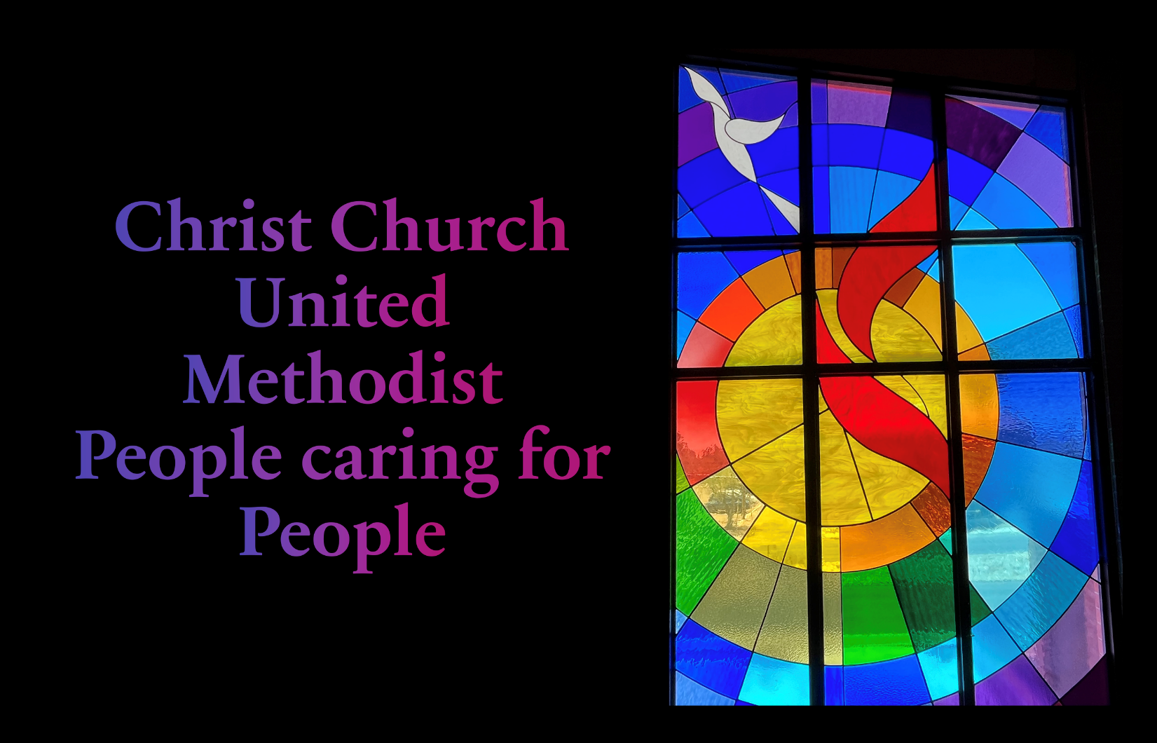

­­­

Tenth Sunday after Pentecost | August 6th, 2023

*Please stand

As you are able

**Welcome and Announcements**

Trinity Chimes

**Prelude**  *How Beautiful* arr. Mark Hayes

**\*Call to Worship:**

One: When we retreat to quiet places to grieve

**All: God, you are there to meet us.**

One: When we are caught up in crowds and mobs

**All: God, you are there to greet us.**

One: When we are hungry in the middle of nowhere

**All: God, you are there to feed us.**

One: Wherever we are,

**All: God, you are there.**

*Hymn of Praise 85 *We Believe in One True Go*d RATISBON

1. We believe in one true God,  
Father, Son, and Holy Ghost,  
ever present help in need,  
praised by all the heavenly host;  
by whose mighty power alone  
all is made and wrought and done.  
  
2. We believe in Jesus Christ,  
Son of God and Mary's Son,  
who descended from his throne  
and for us salvation won;  
by whose cross and death are we  
rescued from sin's misery.  
  
3. We confess the Holy Ghost,  
who from both fore'er proceeds;  
who upholds and comforts us  
in all trials, fears, and needs.  
Blest and Holy Trinity,  
praise forever be to thee!

Opening Prayer

**God, you are the one in the midst of it all.  You feed our spirits when the news of the world is bitter.  You refresh our souls when the wells of our hope run dry.  You nourish our lives when it seems there is nothing left.  Today we come to feast with you, remind us that in the ordinary bread of life, you are present, you are in the midst of us all.  Amen.**

Scripture Lesson Psalm 17:1-7, 15 (UMH 749)

Hear a just cause, O Lord; attend to my cry!

Give ear to my prayer from lips free of deceit!

From you let my vindication come!

Let your eyes see the right!

If you try my heart, if you visit me by night,

if you test me, you will find no wickedness in me;

my mouth does not transgress.

Concerning what others do:

I have avoided the ways of the violent

by following your word.

My steps have held fast to your paths,

My feet have not slipped.

I call upon you, for you will answer me, O God;

incline your ear to me, hear my words.

Wondrously show your steadfast love,

O savior of those who seek refuge

from their adversaries at your right hand.

As for me, I shall behold your face in righteousness;

when I awake I shall be satisfied with beholding your

presence.

Children’s Moment

**Hymn of Preparation** 2202 *Come Away with Me* RECREATION

1. Come away with me to a quiet place,

A part from the world with its frantic

pace, to pray, reflect, and seek God’s grace.

Refrain

Come away with me. Come away.

2. Come and pray with me on a gentle sea,

on top of a hill in the Galilee, in

gardens like Gethsemane.

Refrain

3. Come today with thought of the countless

ways that God’s steadfast love blesses all our

days, and join with me in silent praise.

Refrain

4. Come and say, in words whispered from your

soul, the feelings and actions you can’t control.

Your spirit needs to be made whole.

Refrain

5. Come away with me to a quiet place,

To God’s loving arms waiting to

Embrace all those who come in hope of grace.

Refrain

**Gospel Lesson** Matthew 14:13-21

Sermon Ordinary Bread

Musical Response

*Passing of the Peace

Invitation Offering

Offertory *Seek the Lord* John Carter

Tom Messmore, solo

*Doxology 95 *Praise God, from Whom all Blessings Flow*

Praise God, from whom all blessings flow;

praise him, all creatures here below;

praise him above, ye heavenly host;

praise Father, Son, and Holy Ghost.

Amen.

*Offertory Prayer

Communion

The Lord be with you.

And also with you.

Lift up your hearts.

We lift them up to the Lord.

Let us give thanks to the Lord our God.

It is right to give our thanks and praise.

It is right, and a good and joyful thing,

always and everywhere to give thanks to you,

Almighty God, creator of heaven and earth.

You shaped us from the dust of the earth and breathed life into us, forming humanity in your image.

And so, with your people on earth and all the company of heaven we praise your name and join their unending hymn:

**Holy, holy, holy Lord, God of power and might,**

**Heaven and earth are full of your glory. Hosanna in the highest. Blessed is he who comes in the name of the Lord. Hosanna in the highest.**

Holy are you, and blessed is your Son Jesus Christ.

By the baptism of his suffering, death, and resurrection

you gave birth to your Church, delivered us from our slavery to sin and death, and made with us a new covenant by water and the Spirit.

On the night in which he gave himself up for us, he took bread, gave thanks to you, broke the bread, gave it to his disciples, and said: "Take, eat; this is my body which is given for you. Do this in remembrance of me."

When the supper was over he took the cup,

gave thanks to you, gave it to his disciples, and said:

"Drink from this, all of you; this is the new covenant,

poured out for you and for all for the forgiveness of sins.

Do this, as often as you drink it, in remembrance of me."

And so, in remembrance of these your mighty acts in Jesus Christ, we offer ourselves in praise and thanksgiving as a holy and living sacrifice, in union with Christ's offering for us, as we proclaim the mystery of faith.

Christ has died; Christ is risen; Christ will come again.

Pour out your Holy Spirit on us gathered here, and on these gifts of food and drink. Make them be for us the body and blood of Christ, that we may be for the world the body of Christ, redeemed by his blood.

By your Spirit make us one with Christ,

one with each other, and one in ministry to all the world, until Christ comes in final victory, and we feast at his heavenly banquet. Through your Son Jesus Christ, with the Holy Spirit in your holy Church, all honor and glory is yours, almighty Father (God), now and forever.

Amen

Communion Hymn 599 Break Thou the Bread of Life

BREAD OF LIFE

1. Break thou the bread of life, dear Lord, to me,  
as thou didst break the loaves beside the sea;  
beyond the sacred page I seek thee, Lord;  
my spirit pants for thee, O Living Word!  
  
2. Bless thou the truth, dear Lord, to me, to me,  
as thou didst bless the bread by Galilee;  
then shall all bondage cease, all fetters fall;  
and I shall find my peace, my all in all.

The Lord’s Prayer

Our Father, who art in heaven, hallowed be thy name.

Thy kingdom come, thy will be done, on earth as it is in heaven. Give us this day our daily bread and forgive us our trespasses as we forgive those who trespass against us, and lead us not into temptation, but deliver us from evil, for thine is the kingdom and the power and the glory forever. Amen

*Sending Hymn 672 God Be with You till We Meet Again

GOD BE WITH YOU

1. God be with you till we meet again;  
by his counsels guide, uphold you,  
with his sheep securely fold you;  
God be with you till we meet again.  
Refrain:  
Till we meet, till we meet,  
till we meet at Jesus' feet;  
till we meet, till we meet,  
God be with you till we meet again.  
  
2. God be with you till we meet again;  
neath his wings securely hide you,  
daily manna still provide you;  
God be with you till we meet again.  
(Refrain)  
  
3. God be with you till we meet again;  
when life's perils thick confound you,  
put his arms unfailing round you;  
God be with you till we meet again.  
(Refrain)

*Benediction

May the grace of the Lord Jesus Christ, the love of God and the fellowship of the Holy Spirit be with all.

**Postlude**  *Just a Closer Walk with Thee* arr. Terese Wilhelmi

Liturgist: Ellie Adams

Stephen Minister: Georgia Carmichael

Thank you to all of the volunteers and staff who made this service possible!

ONE LICENSE A-738133 | CCLI #12393 | Perform Music #662 | CVLI #03793174

“We Believe in One True God”

Words: Tobias Clausnitzer, 1668 trans. By Catherine Winkworth, 1863

“Come Away with Me*”*

Words: Mary Nelson Keithahn

“Break Thou the Bread of Lfe”

Words: Mary A. Lathbury, 1877

“God Be with You till We Meet Again”

Words: Jeremiah E. Rankin, 1880

If you have any questions, please call the office: 520.327.1116 or

send us an e-mail: office@ccumtucson.org.

Our Staff contact information

John Neve - Bell Choir Director

[john@ccumtucson.org](mailto:john@ccumtucson.org)

Janet Tolman – Organist

janet@ccumtucson.org

Sinamar Respicio – Choir Director

[choir@ccumtucson.org](mailto:choir@ccumtucson.org)

Mary Beth Buttler – Communications

communications@ccumtucson.org

Candi Eppley – Office Administrator

[office@ccumtucson.org](mailto:office@ccumtucson.org)

Rev. Beth Rambikur

[pastor@ccumtucson.org](mailto:pastor@ccumtucson.org)