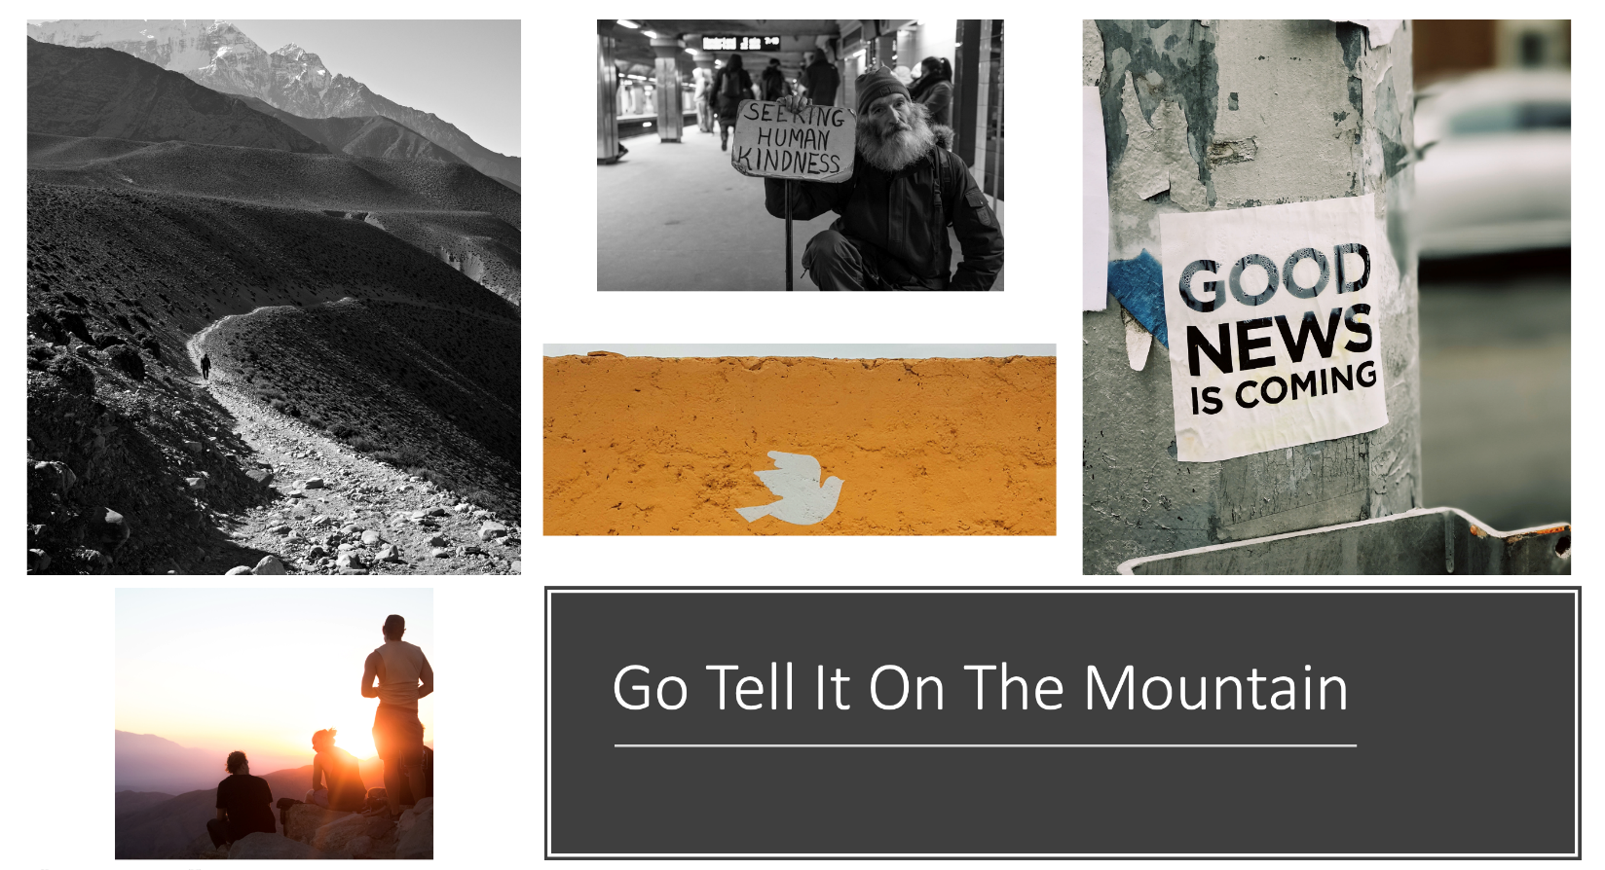

Seventh Sunday after Epiphany | February 19th 2023

But Jesus came and touched them, saying,
“Get up and do not be afraid.”

Matthew 17:7

Christ Church United Methodist | www.ccumtucson.org www.facebook/CCUM.Tucson

*Please stand
As you are able

Welcome and Announcements

Trinity Chimes

Prelude Lord, Here Am I Beck/Sikes
Kathy Ferguson, piano;
Janet Tolman, organ

*Call to Worship:

One: Let us go up the mountain.

All: Let us go up to the place where the land meets the sky

One: Where the earth touches the heavens,

All: Let us go up to the mountain so that we can see all there is!

One: And then let us come back down where life happens,

All: And live as a people who have climbed the mountain, seen the top, and remembered what it means to be a people of vision. Amen.

*Hymn of Praise 2103 We Have Come at Christ's Own Bidding

Tune:HYFRYDOL

1.We have come at Christ’s own bidding to this

high and holy place, where we wait with

hope and longing for some token of God’s grace.

Here we pray for new assurance that our faith is

not in vain, searching like those first disciples

for a sign both clear and plain.

2.Light breaks through our clouds and shadows, splendor

bathes the flesh joined Word, Moses and Elijah

marvel as the heavenly voice is heard.

Eyes and hearts behold with wonder how the Law

and Prophets meet: Christ with garments drenched in

brightness, stands transfigured and complete.

3.Strengthened by his glimpse of glory, fearful

lest our faith decline, we, like Peter, find

it tempting to remain and build a shrine.

But true worship gives us courage to proclaim what

we profess, that our daily lives may

prove us people of the God we bless.

Scripture Reading Matthew 17:1-9

Music of Preparation Holy Ground Christopher Beatty

The Chancel Choir & Doug Holck

Sermon Go Tell It On The Mountain Part 3

Offertory Sweet Hour of Prayer arr. Bradbury

Kathy Ferguson, piano

*Doxology #94 Praise God, From Whom All Blessings Flow

Praise God, from whom all blessings flow;

Praise God, all creatures here below; Alleluia! Alleluia!

Praise God, the source of all our gifts! Praise Jesus Christ, whose

Power up lifts! Praise the Spirit, Holy Spirit!

Alleluia! Alleluia! Alleluia!

Offertory Prayer

Prayers of the People

Confession and Pardon:

Holy God, when you call us up mountains of hope, to actions of grace, we tremble at your presence and cover our eyes. Where you offer a world transformed, we imagine a building. When you send your prophets and Messiah who offer us the Kingdom, we hear interesting words and good ideas. While you overshadow us with love and forgiveness, we keep score of wrongs and loss. Yet you call us beloved and invite us to rise and be unafraid. Let us live as a people who have been transfigured by the mountaintops of faith, who fear no valley, and who extend grace and forgiveness to all!

Leader: Hear the good news: God walked upon this earth sharing our human life in Jesus Christ,

All: God has conquered sin and death forgiving us all through Love and Grace

Leader: In the name of Christ, you are forgiven!

People: In the name of Christ, you are forgiven!

All: Glory to God, amen!

The Lord’s Prayer

Our Father, who art in heaven, hallowed be thy name.

Thy kingdom come, thy will be done, on earth as it is in heaven. Give us this day our daily bread and forgive us our trespasses as we forgive those who trespass against us, and lead us not into temptation, but deliver us from evil, for thine is the kingdom and the power and the glory forever. Amen

*Sending Hymn 2102 Swiftly Pass the Clouds of Glory

BEECHER

1.Swiftly pass the clouds of glory,

Heaven’s voice the dazzling light; Moses and

Elijah vanish: Christ alone commands the height!

Peter, James, and John fall silent,

Turning from the summit’s rise downward

Towards the shadowed valley where their Lord

Has fixed his eyes.

2.Glimpsed and gone the revelation,

they shall gain and keep its truth, not by building

on the mountain any shrine or sacred booth,

but by following the Savior through the valley

to the cross and by testing faith’s resilience

through be betrayal, pain and loss.

3.Lord, transfigure our perception with

the purest light that shines and recast our

life’s intentions to the shape of your designs,

til we seek no other glory than what lies past

Calvary’s hill and our living and our

dying and our rising by your will.

*Benediction

May the Creator who brings light from darkness,

The Spirit who transfigures our fears to forms of hope,

And the Christ who lifts up valleys and brings the mountain’s glory down to earth, make the rough places plain before us and bless us this day and always. Amen!

Postlude The Promised Land Beck/Sikes

Kathy Ferguson, piano;

Janet Tolman, organ

Thank you to all of the volunteers and staff who made this service possible!

Liturgist: Paula Jameson

Stephen Minister: Michael Edwards

ONE LICENSE A-738133 | CCLI #12393 | Perform Music #662 | CVLI #03793174

“We Have Come at Christ’s Own Bidding”

Words: Carl P Daw, Jr

“Swiftly Pass the Clouds of Glory”

Words: Thomas H Troeger

If you have any questions, please call the office: 520.327.1116 or

send us an e-mail: office@ccumtucson.org.

Our Staff contact information

John Neve - Bell Choir Director

john@ccumtucson.org

Janet Tolman – Organist

janet@ccumtucson.org

Sinamar Respicio – Choir Director

choir@ccumtucson.org

Mary Beth Buttler – Communications

communications@ccumtucson.org

Candi Eppley – Office Administrator

office@ccumtucson.org

Rev. Beth Rambikur

pastor@ccumtucson.org

NOTES

