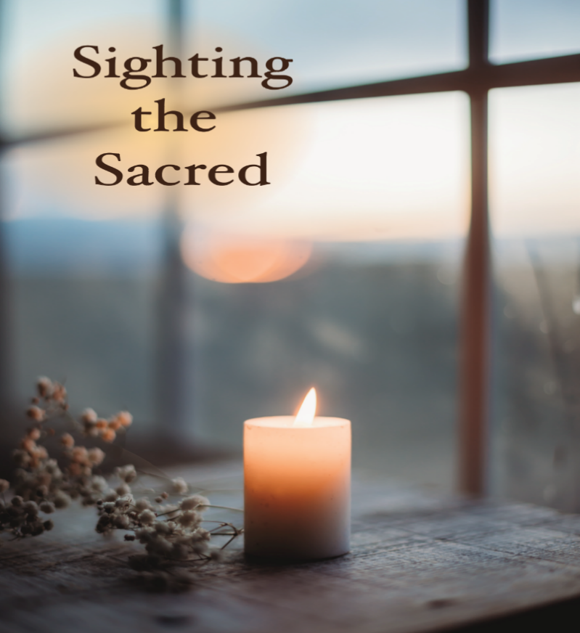­­­

*Sighting the Sacred*

Second Sunday of Advent | December 4, 2022

“The Voice of One Crying out in the Wilderness: Prepare the way of the Lord;

Make his Paths Straight”

Matthew 3:3b



Christ Church United Methodist | [www.ccumtucson.org](http://www.ccumtucson.org) www.facebook/CCUM.Tucson

*\*Please stand*

**Welcome and Announcements**

Trinity Chimes

**Prelude**  *Comfort, Comfort Ye My People* Paul Manz

*Call to Worship:

One: Into the wild places of our lives God’s word proclaims

All: Repent, for the Kingdom draws near!

One: What does it mean to return to God this season, what shall we do to prepare the way?

All: Turn towards this sacred arrival and join the proclamation rejoicing for salvation is here.

*Hymn of Praise 203 *Hail to the Lord's Anointed*

ELLACOMBE

1. Hail to the Lord's Anointed,  
great David's greater Son!  
Hail in the time appointed,  
his reign on earth begun!  
He comes to break oppression,  
to set the captive free;  
to take away transgression,  
and rule in equity.  
  
2. He comes with succor speedy  
to those who suffer wrong;  
to help the poor and needy,  
and bid the weak be strong;  
to give them songs for sighing,  
their darkness turn to light,  
whose souls, condemned and dying,  
are precious in his sight.

3. He shall come down like showers  
upon the fruitful earth;  
love, joy, and hope, like flowers,  
spring in his path to birth.  
Before him on the mountains,  
shall peace, the herald, go,  
and righteousness, in fountains,  
from hill to valley flow.  
  
4. To him shall prayer unceasing  
and daily vows ascend;  
his kingdom still increasing,  
a kingdom without end.  
The tide of time shall never  
his covenant remove;  
his name shall stand forever;  
that name to us is love.

Advent Candle Lighting:

Reader 1: John cries out in the wilderness “you brood of vipers! Who warned you to flee the wrath to come?”

Reader 2: And Jesus responds, “Peace I leave with you; my peace I give to you. I do not give to you as the world gives. Do not let your hearts be troubled, and do not let them be afraid.”

Reader 1: John shouts, “I baptize you with water for repentance, but the one who is coming will baptize you with the Holy Spirit and fire.”

Reader 2: Jesus says, “the Advocate, the Holy Spirit, whom the Father will send in my name, will teach you everything and remind you of all that I have said to you.”

Reader 1: We turn to you, O God, seeking your salvation in the midst of turbulent times,

Reader 2: Speak to us once more through wandering prophets using wild words to spark hope for change.

**All: Speak to us once more of your peace that surpasses understanding and teach us to share that peace with all the world. Amen.**

**Advent Hymn:** *O Come, O Come, Emmanuel*

VENI EMMANUEL

O Come O come Emmanuel

and save your people Israel

We wait for you to give us a sign

Your Living Word,

your Son divine

Rejoice, Rejoice,

Emmanuel shall come to us O Israel.

**Scripture Reading** Matthew 3:1-12

**Children’s Moment**

*All Children are invited to come up to the front and after words go to Sunday School*

Music of Preparation *Come, Emmanuel*  Mary McDonald

The Chancel Choir

Sermon In the Wild

*Music of Response 216 *Lo, How a Rose E'er Blooming*

ES IST EIN ROS

1. Lo, how a Rose e'er blooming

from tender stem hath sprung!

Of Jesse's lineage coming,

as those of old have sung.

It came, a floweret bright,

amid the cold of winter,

when half spent was the night.

2. Isaiah 'twas foretold it,

the Rose I have in mind;

with Mary we behold it,

the Virgin Mother kind.

To show God's love aright,

she bore to us a Savior,

when half spent was the night.

**Holy Communion**

Pastor: The Lord is with us!

**All: Emmanuel has come to dwell.**

Pastor: He has raised up a mighty savior for us

**All: To give light to those who sit in darkness and in the shadow of death, to guide our feet in the way of peace.**

Pastor: Eternal God, from your spark, your Divine Imagination, a Universe of Wonder, galaxies, stars, worlds, beings, all come into existence. You have placed each in this world to offer hope and share joy so that we might turn toward each other with compassion and generosity. When our love fails, your grace holds us tenaciously. Today we praise You for the wonders of your love and come to your table to feast with all creation on your sustaining Grace, and so we declare.

**Holy, holy, holy Lord, God of power and might,**

**heaven and earth are full of your glory. Hosanna in the highest. Blessed is he who comes in the name of the Lord. Hosanna in the highest.**

Pastor: Holy are you, and blessed is your Son Jesus Christ, whom you sent in the fullness of time to be a light to the nations, to give knowledge of salvation to all people and teach us forgiveness and grace. He was, and is Emmanuel, your presence with us.

On the night in which he gave himself up for us, he took bread,

gave thanks to you, broke the bread, gave it to his disciples, and said:

"Take, eat; this is my body which is given for you. Do this in remembrance of me."

When the supper was over he took the cup, gave thanks to you, gave it to his disciples, and said:

"Drink from this, all of you; this is my blood of the new covenant, poured out for you and for many for the forgiveness of sins. Do this, as often as you drink it, in remembrance of me."

And so, in remembrance of these your mighty acts in Jesus Christ, we offer ourselves in praise and thanksgiving as a holy and living sacrifice, in union with Christ's offering for us, as we proclaim the mystery of faith.

**Christ has died; Christ is risen; Christ will come again.**

Pour out your Holy Spirit on us gathered here, and on this gift of food and drink. Let this be for us the grace and love of Christ, that we may be for the world the body of Christ, redeemed. By your Spirit make us one with Christ, one with each other, and one in ministry to all the world, until Christ comes in final victory, and we feast at his heavenly banquet.

**Through your Son Jesus Christ, with the Holy Spirit in your holy Church, all honor and glory are yours, almighty God, now and forever.**

**Amen.**

Communion Hymn *Thank You, Jesus* (3x) TINO TENDA

Thank you, Jesus, amen! Thank you, Jesus, amen!

Thank you, Jesus, amen! Alleluia Amen!

The Lord’s Prayer:

Our Father, who art in heaven, hallowed be thy name.

Thy kingdom come, thy will be done, on earth as it is in heaven. Give us this day our daily bread and forgive us our trespasses as we forgive those who trespass against us, and lead us not into temptation, but deliver us from evil, for thine is the kingdom and the power and the glory forever. Amen

*Sending Hymn 209 *Blessed Be the God of Israel*

MERLE'S TUNE

1. Blessed be the God of Israel, who comes to set us free, who visits and redeems us, and grants us liberty. The prophets spoke of mercy, of freedom and release; God shall fulfill the promise to bring our people peace.

2. Now from the house of David a child of grace is given; a Savior comes among us to raise us up to heaven. Before him goes the herald, forerunner in the way, the prophet of salvation, the harbinger of day.

3. On prisoners of darkness the sun begins to rise, the dawning of forgiveness up on the sinner’s eyes, to guide the feet of pilgrims along the paths of peace; O bless our God and Savior with songs that never cease!

Benediction

May worry give way to wonder and busyness to blessedness.

May promise become fulfillment as time reveals God’s eternal Love. May we seek out sightings of the Sacred and participate with God in the coming of Emmanuel. Amen.

Postlude *Savior of the Nations Come* J. S. Bach

Thank you to all of the volunteers and staff who made this service possible!

Liturgist: Iris Washburn

Stephen Minister: Georgia Carmichael

Guest Organist: David Gay

ONE LICENSE A-738133 | CCLI #12393 | Perform Music #662 | CVLI #03793174

“O Come, O Come, Emmanuel”

Words: Beth Rambikur 2020

“Hail to the Lord’s Anointed

Words: James Montgomery, 1821

“Lo, How a Rose E’er Blooming

Words: Theodore Baker, 1894

“Thank You, Jesus”

Words: Patrick Matsikenyiri (Ps. 118:21; Rev. 11:17; 19:4)

“Blessed Be the God of Israel”

Words: Michael Perry, 1973

If you have any questions, please call the office: 520.327.1116 or

send us an e-mail: office@ccumtucson.org.

*NOTES*