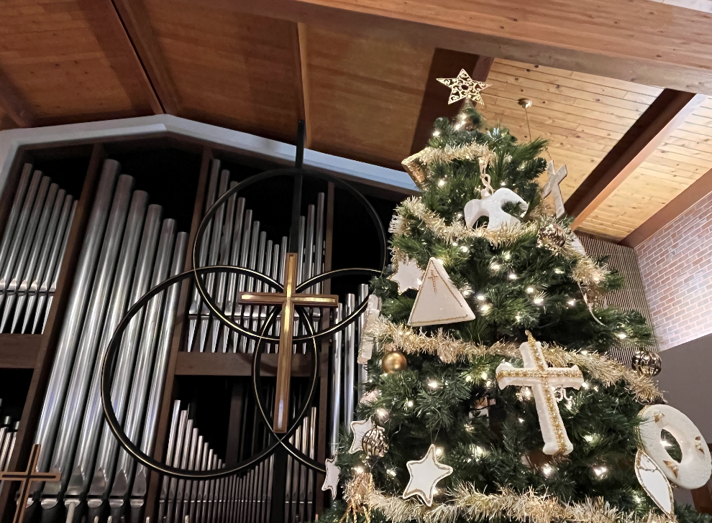

Sighting the Sacred

Merry Christmas| December 25, 2022

All this took place to fulfill what had been spoken by the Lord through the prophet:
‘Look, the virgin shall conceive and bear a son,
and they shall name him Emmanuel’,
which means, ‘God is with us.’
Matthew 1:22-23

Christ Church United Methodist | www.ccumtucson.org www.facebook/CCUM.Tucson

*Please stand

Welcome and Announcements

Trinity Chimes

Prelude In Dulci Jubilo arr. Smith

*Call to Worship

One: Sing to the Lord a new song,

All: Let all the ends of the earth, the multitudes of heaven sing with joyous praise!

One: For Christ is born today!

All: God’s Love placed in our arms, God’s dream held in our hands, glory to God, and peace to all the earth. Amen.

*Hymn of Praise Once in Royal David’s City #250

1. Once in royal David's city

stood a lowly cattle shed,

where a mother laid her baby

in a manger for his bed;

Mary, loving mother mild,

Jesus Christ, her little child.

2. He came down to earth from heaven

who is God and Lord of all,

and his shelter was a stable,

and his cradle was a stall.

With the poor, the scorned, the lowly

lived on earth our Savior holy.

3. Jesus is our childhood's pattern;

day by day, like us he grew;

he was little, weak, and helpless,

tears and smiles like us he knew;

and he feeleth for our sadness,

and he shareth in our gladness.

4. And our eyes at last shall see him,

through his own redeeming love;

for that child so dear and gentle

is our Lord in heaven above;

and he leads his children on

to the place where he is gone.

Lighting the Candles
Reader 1: Advent was a season of waiting, Christmas is the season of arrival.

Reader 2: Mary and Joseph have arrived, Christ has arrived, the angels, shepherds, and wise men have arrived, and so have we.

Reader 1: So now our work is seeking out Christ’s light everywhere we look:

Reader 2: In our own lives
All: We are seeking Christ’s light

Reader 1: In our families and friendships
All: We are seeking Christ’s light

Reader 2: In all the places we find and build community
All: We are seeking Christ’s light

Reader 1: The message of Christmas is that God’s light can overcome every place of darkness.

Reader 2: As we light these candles of hope, peace, joy, and love we remember that these gifts of light can transform every darkness we experience.

All: And as we light the Christ candle we remember that we are called to be the light so that the world can see the love and grace of God at work. Amen.

Hymn In the Bleak Midwinter #221

1. In the bleak midwinter, frosty wind made moan,

earth stood hard as iron, water like a stone;

snow had fallen, snow on snow, snow on snow,

in the bleak midwinter, long ago.

2. Our God, heaven cannot hold him, nor earth sustain;

heaven and earth shall flee away when he comes to reign.

In the bleak midwinter a stable place sufficed

the Lord God Almighty, Jesus Christ.

3. Angels and archangels may have gathered there,

cherubim and seraphim thronged the air;

but his mother only, in her maiden bliss,

worshiped the beloved with a kiss.

4. What can I give him, poor as I am?

If I were a shepherd, I would bring a lamb;

if I were a Wise Man, I would do my part;

yet what I can I give him: give my heart.

Scripture Matthew 1:18-25 and John 1:1-14

Music of Preparation O Little Town of Bethlehem H. Sorenson

The Christ Church Chancel Choir

Sermon Dreams and Visions Part 1

Hymn of Response What Child Is This #219

1. What child is this who, laid to rest,
on Mary's lap is sleeping?
Whom angels greet with anthems sweet,
while shepherds watch are keeping?
Refrain:
This, this is Christ the King,
whom shepherds guard and angels sing;
haste, haste to bring him laud,
the babe, the son of Mary.
2. Why lies he in such mean estate
where ox and ass are feeding?
Good Christians, fear, for sinners here
the silent Word is pleading.
(Refrain)
3. So bring him incense, gold, and myrrh,
come, peasant, king, to own him;
the King of kings salvation brings,
let loving hearts enthrone him.
(Refrain)

Offertory "Lo, how a Rose" Praetorius

Celebrating our Gifts and Offerings

Prayers of the People

Confession and Pardon

All: Emmanuel, you have surprised us with your presence in unexpected ways. In the expectations of our routine, we have missed the treasure that you place before us, in the rush of life we miss the visions and dreams you offer. We begin our days, our weeks, assuming all will run as it always has. We do not look for the unexpected, for your active presence in our daily lives, we do not seek the sacred in the ordinary. Forgive us, give us eyes to see, ears to hear, and words to proclaim as we glimpse your glory in the ordinary! Amen.

Leader: Hear the good news: God walked upon this earth sharing our human life in Jesus Christ,

All: God has conquered sin and death forgiving us all through Love and Grace

Leader: In the name of Christ, Emmanuel, you are forgiven!

People: In the name of Christ our Emmanuel, you are forgiven!

All: Glory to God, amen!

The Lord’s Prayer

Our Father, who art in heaven, hallowed be thy name.

Thy kingdom come, thy will be done, on earth as it is in heaven. Give us this day our daily bread and forgive us our trespasses as we forgive those who trespass against us, and lead us not into temptation, but deliver us from evil, for thine is the kingdom and the power and the glory forever. Amen

*Sending Hymn Good Christian Friends, Rejoice #224

1 Good Christian friends, rejoice

with heart and soul and voice;

give ye heed to what we say:

News, news!

Jesus Christ is born today!

Ox and ass before him bow,

and he is in the manger now.

Christ is born today,

Christ is born today!

2 Good Christian friends, rejoice,

with heart and soul and voice;

now ye hear of endless bliss:

News, news!

Jesus Christ was born for this!

He hath opened heaven's door,

and ye are blest forevermore.

Christ was born for this,

Christ was born for this!

3 Good Christian friends, rejoice,

with heart and soul and voice;

now ye need not fear the grave:

News, news!

Jesus Christ was born to save!

Calls you one and calls you all

to gain his everlasting hall.

Christ was born to save,

Christ was born to save!

*Benediction

We have come to adore!

Rejoicing with heart and soul and voice,

for God, who cannot be contained by heaven or earth,

has been born among us, as Christ!

So let us proclaim to all the world,

these wonders of God’s love. Merry Christmas!

Postlude The First Noel arr. Moffatt

Thank you to all of the volunteers and staff who made this service possible!

Liturgist: Iris Washburn

Stephen Minister: Gretchen Lofgren

Guest Organist: Susan Schild

ONE LICENSE A-738133 | CCLI #12393 | Perform Music #662 | CVLI #03793174

“Once in Royal David’s City”

Words: Cecil Frances Alexander, 1848

“In the Bleak Midwinter”

Words:Christina G Rossetti, 1872

“What Child Is This”

Words: William C Dix, 1865

“Good Christian Friends, Rejoice”

Words: 14th cent. Latin; trans. by John Mason Neale, 1855

If you have any questions, please call the office: 520.327.1116 or

send us an e-mail: office@ccumtucson.org.

NOTES

