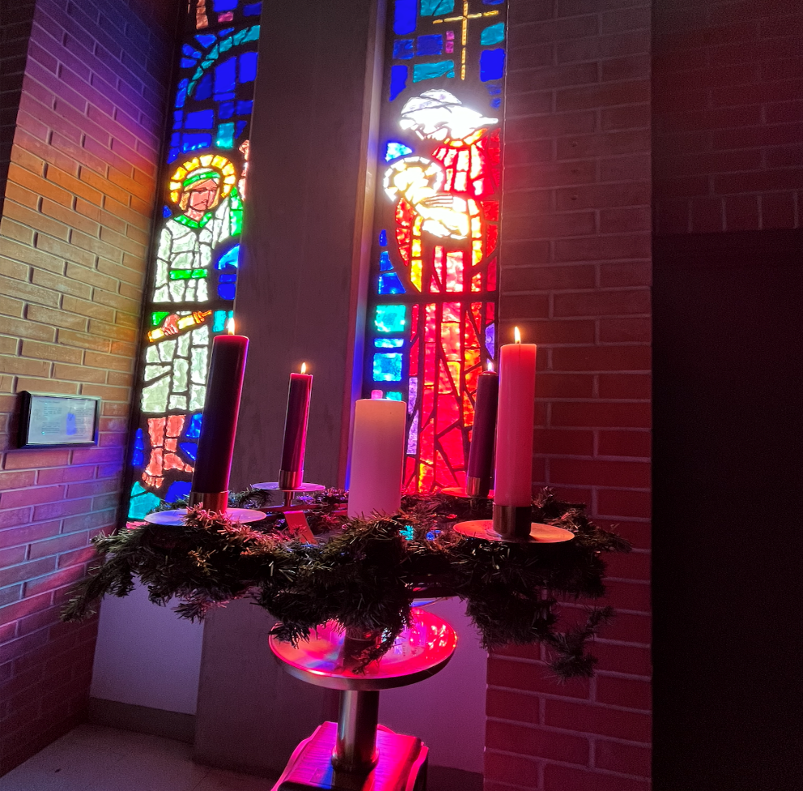

Christmas Eve | December 24, 2022
7PM Service

“In him was life, and the life was the light of all people. The light shines in the darkness, and the darkness did not overcome it.” John 1:4-5

Christ Church United Methodist | www.ccumtucson.org www.facebook/CCUM.Tucson

*Please stand

Gathering Music Played during

Fum, fum, fum ---Richard Lind

Lo how a rose ‘er Blooming --- Johannes Brahms

Quem pastores -- Helmut Walcha

Go tell it on the mountain --- David Lasky

Once in royal David’s city --- Robert Buckely Farlee

Welcome

Trinity Chimes

Prelude Good Christian Friends Rejoice J.S. Bach

*Call to Worship

Leader: We sight the sacred in everything.

All: Light strings and evergreens, singing choirs, and quiet dreams.

Leader: We sight the sacred in everything.

All: Stories read by candle glow, God revealed for all to know.

Leader: For these sacred sightings now become

All: Our participation in God’s love for Everyone!

*Processional Carol #234 O Come, All Ye Faithful

1. O come all ye faithful, joyful and triumphant,
O come ye, O come ye, to Bethlehem.
Come and behold him, born the King of angels;
Refrain:
O come let us adore him, O come let us adore him,
O come let us adore him, Christ the Lord.

3. Sing, choirs of angels, sing in exultation;

O sing, all ye citizens of heaven above!

Glory to God, all glory in the highest:

(Refrain)

5. Child, for us sinners poor and in the manger,

we would embrace thee with love and awe.

Who would not love thee, loving us so dearly?

(Refrain)

6. Yea, Lord, we greet thee, born this happy morning,

Jesus, to thee be all glory given.

Word of the Father, now in flesh appearing:

(Refrain)

Lighting of the Advent Candles

Reader 1: Advent is a season of waiting; we wait with friends, with family, we wait for news, we wait for Christmas, but most importantly we wait with God.

Reader 2: We wait with God as God speaks the world into creation, speaks light into being, we wait with God whose living word is Hope incarnate!

Reader 1: God’s Hope speaks to us once more through wandering shepherds and visions of angels giving us a peace that surpasses understanding and teaching us to share that peace with all the world.

Reader 2: A peace which causes joy to burst forth from challenge, releasing us from all that holds us captive, and healing all that is broken.

Reader 1: A joy given to all the world for the Lord of Life has been born, Emmanuel comes among us God’s love made human, to be held by us, nurtured, treasured, and raised by us.

Reader 2: What wondrous love is this? God’s love, joy, peace, and hope made present to us all in Christ.

All: As we see again this sacred work of love, we too participate in this story of salvation. We come as the shepherds and wise men, angels and onlookers – as adults and children, learners and wanderers, people seeking the sacred born among us tonight. Light our way, O God, Emmanuel.

Candle Lighting Hymn O come, o come Emmanuel

O come new dawn and break upon us here,

disperse the dark of night, the clouds of fear.

Our God has sent His Son to earth,

a reign of peace and love in this new birth.

Rejoice, rejoice, Emmanuel has come to us O Israel!

Scripture Genesis 1:26-31, 3:6-13, 3:22-23

Reflection 1

Anthem O Little Town of Bethlehem The Chancel Choir

Scripture Isaiah 9:2-7, 11:1-9

Reflection 2

Second Carol #220 Angles from the Realms of Glory

1. Angels from the realms of glory,

wing your flight o'er all the earth;

ye who sang creation's story

now proclaim Messiah's birth:

Refrain:

Come and worship, come and worship,

worship Christ, the newborn king.

2. Shepherds, in the field abiding,

watching o'er your flocks by night,

God with us is now residing;

yonder shines the infant light:

(Refrain)

3. Sages, leave your contemplations,

brighter visions beam afar;

seek the great Desire of nations;

ye have seen his natal star:

(Refrain)

4. Saints, before the altar bending,

watching long in hope and fear;

suddenly the Lord, descending,

in his temple shall appear:

(Refrain)

Scripture Luke 1:26-38 and Matthew 1:18-24

Reflection 3

Third Carol # 240 Hark! The Herald Angels Sing

1. Hark! the herald angels sing,

"Glory to the new born King,

peace on earth, and mercy mild,

God and sinners reconciled!"

Joyful, all ye nations rise,

join the triumph of the skies;

with th' angelic host proclaim,

"Christ is born in Bethlehem!"

Hark! the herald angels sing,

"Glory to the new born King!"

2. Christ, by highest heaven adored;

Christ, the everlasting Lord;

late in time behold him come,

offspring of a virgin's womb.

Veiled in flesh the Godhead see;

hail th' incarnate Deity,

pleased with us in flesh to dwell,

Jesus, our Emmanuel.

Hark! the herald angels sing,

"Glory to the new born King!"

3. Hail the heaven-born Prince of Peace!

Hail the Sun of Righteousness!

Light and life to all he brings,

risen with healing in his wings.

Mild he lays his glory by,

born that we no more may die,

born to raise us from the earth,

born to give us second birth.

Hark! the herald angels sing,

"Glory to the new born King!"

Scripture Luke 2:1-7

Fourth Carol # 217 Away in a Manger

1. Away in a manger, no crib for a bed,

the little Lord Jesus laid down his sweet head.

The stars in the sky looked down where he lay,

the little Lord Jesus, asleep on the hay.

2. The cattle are lowing, the baby awakes,

but little Lord Jesus, no crying he makes;

I love thee, Lord Jesus, look down from the sky

and stay by my cradle till morning is nigh.

3. Be near me, Lord Jesus, I ask thee to stay

close by me forever, and love me, I pray;

bless all the dear children in thy tender care,

and fit us for heaven to live with thee there.

Scripture Luke 2:8-20

Fifth Carol # 238 Angels We Have Heard on High

1. Angels we have heard on high

sweetly singing o'er the plains,

and the mountains in reply

echoing their joyous strains.

Refrain:

Gloria, gloria, gloria, gloria,

in excelsis Deo!

Gloria, gloria, gloria, gloria,

in excelsis Deo!

2. Shepherds, why this jubilee?

Why your joyous strains prolong?

What the gladsome tidings be

which inspire your heavenly song?

(Refrain)

3. Come to Bethlehem and see

Christ whose birth the angels sing,

come, adore on bended knee,

Christ the Lord, the newborn King.

(Refrain)

4. See him in a manger laid,

whom the choirs of angels praise,

Mary, Joseph, lend your aid,

while our hearts in love we raise.

(Refrain)

Scripture Matthew 2:1-12

Reflection 4

Sixth Carol #251 Go, Tell It on the Mountain

Refrain:

Go tell it on the mountain,

over the hills, and everywhere;

go, tell it on the mountain

that Jesus Christ is born.

1. While shepherds kept their watching

o’er silent flocks by night,

behold, throughout the heavens

there shone a holy light. [Refrain]

2. The shepherds feared and trembled

when lo, above the earth

rang out the angel chorus

that hailed our Savior’s birth. [Refrain]

3. Down in a lowly manger

the humble Christ was born,

and God sent us salvation

that blessed Christmas morn. [Refrain]

Offertory In the Bleak Midwinter arr. B. Austin

The Christ Church Ringers

*Doxology #95

Prayer Praise God, From Whom All Blessings Flow

Praise God, from whom all blessings flow;

praise Him, all creatures here below;

praise Him above, ye heavenly host;

praise Father, Son, and Holy Ghost.

Amen.

Lighting of the Christ Candle

In the beginning was the Word,

and the Word was with God,

and the Word was God.

He was in the beginning with God.

All things came into being through him,

and without him not one thing came into being.

What has come into being in him was life,

and the life was the light of all people.

The Light Shines in the darkness,

and the darkness does not overcome it.

Special Music Prelude on Stille Nacht arr. D. Wagner

Christ Church Ringers

Seventh Carol #239 Silent Night

1. Silent night, holy night,

all is calm, all is bright

round yon virgin

mother and child.

Holy infant, so tender and mild,

sleep in heavenly peace,

sleep in heavenly peace.

2. Silent night, holy night,

shepherds quake at the sight;

glories stream from heaven afar,

heavenly hosts sing Alleluia!

Christ the Savior is born,

Christ the Savior is born!

3. Silent night, holy night,

Son of God, love's pure light;

radiant beams from thy holy face

with the dawn of redeeming grace,

Jesus, Lord, at thy birth,

Jesus, Lord, at thy birth.

4. Silent night, holy night,

wondrous star, lend thy light;

with the angels let us sing,

Alleluia to our King;

Christ the Savior is born,

Christ the Savior is born!

*Benediction

*Sending Carol #246 Joy to the World

1. Joy to the world, the Lord is come!

Let earth receive her King;

let every heart prepare him room,

and heaven and nature sing,

and heaven and nature sing,

and heaven and nature sing.

2. Joy to the world, the Savior reigns!

Let all their songs employ;

while fields and floods, rocks, hills, and plains

repeat the sounding joy,

repeat the sounding joy,

repeat the sounding joy.

3. No more let sins and sorrows grow,

nor thorns infest the ground;

he comes to make his blessings flow

far as the curse is found,

far as the curse is found,

far as the curse is found.

4. He rules the world with truth and grace,

and makes the nations prove

the glories of his righteousness,

and wonders of his love,

and wonders of his love,

and wonders of his love.

Liturgist: Don Finch and Paula Jameson

Stephen Minister: Carol Swango

Guest Organist: David Gay

ONE LICENSE A-738133 | CCLI #12393 | Perform Music #662 | CVLI #03793174

“O Come, All Ye Fathful”

Words: Czech carol; trans. by Jaroslav J Vajda, 1987

“O Come, o come Emmanuel”

Words:Beth Rambuker

“Angels from the Realms of Glory”

Words:James Montomery, 1816

“Angels we have heard on high”

“Hark! the Herald Angels Sing”

Words:Charles Wedley, 1734 alt. by George Whitefield, 1753

“Go Tell It on the Mountain”

Words:Afro-American Spirtual; adapt.by John W Work Jr 1907

“Joy to the World”

Words:Issac Watts, 1719

“Away in a Manger”

Words:Trad.French carol; Crown of Jesus 1862

“Silent Night”

Words:Joseph Mohr, 1818 alt; sts. 1,2,3 John F Young

If you have any questions, please call the office: 520.327.1116 or

send us an e-mail: office@ccumtucson.org.

Notes

