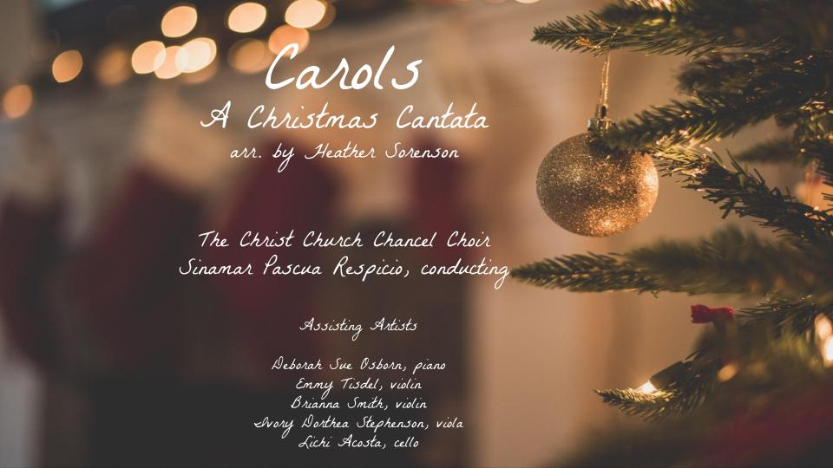

Sighting the Sacred

Forth Sunday of Advent | December 18, 2022

Christ Church United Methodist | www.ccumtucson.org www.facebook/CCUM.Tucson

*Please stand

Welcome and Announcements

Trinity Chimes

Prelude Allemande from JS Bach Cello Suite
Lichi Acosta, cello

*Call to Worship:

One: Joy to the world! Our Lord has come! He is here! He has accomplished the Gospel. He is a living testament that God keeps His promises.

Lord, like the Holy Family on that first Christmas night, many of us enter into the Christmas season with mixed emotions. And like that first Christmas night, we celebrate in the midst of a complicated, ever-changing world. Because You are good, through Your Birth You remind us that You are our Eternal, faithful God. Because of this,

All: We come today in gratitude

One: knowing that as far as the curse is found, your Light shines. As far as the curse is found, your blessings search us out and cover us.

All: We come today in humility

One: Stripped of pride, accepting You as our eternal Gift, given by God the Father.

All: We come rejoicing

One: as Your adopted children! Your earthly adoption brought You into a world of heartache, poverty, and death. Our heavenly adoption brings us kingdom riches and life.

All: We come in faith

One: knowing that in our advent seasons of life, you are the Promise Keeper. You are the God who comes and stays and delivers. Because of this,

All: You are our Hope!

One: Our Hope for things to come,

All: Our Hope for unresolved situations today.

You are our HOPE, bringing Joy to the world, Amen.

*Processional Hymn Joy to the World

Advent Candle Lighting

Reader 1: God, you come into our lives, through signs of wonder bringing hope, peace, joy, and love.

Reader 2: We light these candles, the candle of joyous hope, of proclaimed peace, of deep everlasting joy, and today of presence that speaks of love, as a sign that no matter our circumstance, we know we are not alone.

All: Let us sing in all the ways we can of the wonders of your love. Amen.

Scripture Luke 2:1-7

Reader 1: And it came to pass in those days that a decree went out from Caesar Augustus that all the world should be registered. This census first took place while Quirinius was governing Syria. So all went to be registered, everyone to his own city.

Reader 2: Joseph also went up from Galilee, out of the city of Nazareth, into Judea, to the city of David, which is called Bethlehem, because he was of the house and lineage of David, to be registered with Mary, his betrothed wife, who was with child.

Reader 1: So it was, that while they were there, the days were completed for her to be delivered. And she brought forth her firstborn Son, and wrapped Him in swaddling clothes, and laid Him in a manger, because there was no room for them in the inn.

One: Lord, it is beyond our comprehension that our Royal Prince, our Holy Messiah would have no place to lay His Head. While we shake our heads in disapproval, we must also ask ourselves where we have not made room for You. So today, Lord,

All: We invite You into our homes

One: The place where we are the most vulnerable and real. We invite You to see us as we are, with no pretense or show; to see the best and worst of us.

All: We create room for You in our workplaces

One: Where tensions often run high, and people can be difficult.

All: We invite You into our conflicts

One: Drawing on Your divine compassion, understanding, and wisdom to resolve situations that wound us.

All: We create room for You in our physical life.

One: So that You can guide us to people in need, precious souls beloved by You. And for those who struggle during the Christmas season,

All: We invite You into our struggle

One: Embracing You as our Prince of Peace, our Wonderful Counselor. May every heart prepare room for You in this season and throughout the year.

All: Amen.

Second Carol Away in a Manger

With Christ Church Children and Youth

A Moment for AMEN

Reader 1: Here we are to be invited to the very first Call to Worship,

Reader 2: To be summoned to the stable where the curse was reversed,

Reader 1: To have “A Request for the Honor of Your presence” from the King of the Nations.

All: How can we refuse?!

Reader 1: In answer to Your bidding we will go.

Reader 2: With uplifted hearts and outstretched arms:

All: We will go.

Reader 1: Joining our voices with the angels:

All: We will go.

Reader 2: With joyful songs and happy greetings: “All the earth bows down to You; they sing praise to You; they sing praise to Your name

All: We come and see the works of God; how awesome are His deeds toward humankind!” (psalm 66:4-5)

Third Carol O Come All Ye Faithful

Reader 1: What words we sing! “O come, all ye faithful, joyful and triumphant!” Our invitation to meet the Savior. And yet, who can live up to that standard? These words which describe us on our best days - faithful, joyful, triumphant - also seem to disqualify us, as we all occasionally miss the mark.

Reader 2: What about the unfaithful? The broken? The defeated? Can we also come to Bethlehem and meet the Savior? Because if we’re honest with ourselves, we have all been unfaithful. We have all strayed and turned to our own way.

Reader 1: The Good News of Christmas is that Christ was born specifically for the unfaithful. He came to gather the broken, the disillusioned, the weary and the utterly defeated to Himself for healing. He breaks the power of fear and sin, and he frees us, giving us His peace.

All: As Jesus says “Come to me, all who labor and are heavy laden, and I will give you rest. Take my yoke upon you, and learn from me, for I am gentle and lowly in heart, and you will find rest for your souls.” (Matthew 11:28-29)

Reader 1 & 2 together: What tidings of Comfort! These are the tidings of joy!

Fourth Carol God rest ye Merry, Gentlemen

Reader 1: But you, O Bethlehem Ephrathah, who are too little to be among the clans of Judah, from you shall come forth for me, one who is to be ruler in Israel, whose coming forth is from of old, from ancient days…

Reader 2: And he shall stand and shepherd his flock in the strength of the Lord, in the majesty of the name of the Lord his God. And they shall dwell secure, for now, he shall be great to the ends of the earth. And he shall be their peace. (Micah 5:2, 4-5a)

Reader 1: Because our culture pushes us to look for the extraordinary in exaggerated situations, we are prone to miss miracles that happen in unlikely places. We might be tempted to manufacture glamour in efforts to see God’s hand at work.

Reader 2: Lord, remind us that throughout history, you have chosen the underdog, the unassuming to show Your greatest power.

All: Remind us that You can be found in the most unlikely of places.

Reader 1: Remind us that Your miracles and blessings cannot be summoned by wealth, power, or presentation.

All: In times when we lack confidence in our calling,

Reader 2: Remind us that you chose Mary, an unwed teen, to raise the Savior of the world.

All: in times when our current situation seems to disqualify us from Your blessings,

Reader 1: Remind us of Bethlehem, a tiny city with heavenly fame.

All: in times when we feel “less-than,”

Reader 2: Remind us that You are the Great I AM. When we act justly, love mercy, and walk humbly with You, we are in partnership with the Almighty. That You would use us to accomplish the divine is an honor almost more than we can comprehend, but we are grateful!

All: Let us be Your hands and feet, bringing miracles of hope and deliverance to people in darkness. AMEN.

Fifth Carol O Little Town of Bethlehem

Paula Jameson, solo

Invitation to Offering

Offertory - Of the Father's Love Begotten arr. Mark Hayes

Deborah Sue Osborn, piano

*Celebration of our Gifts and Offerings

Scripture Luke 2:8-18

Reader 1: Now there were in the same country shepherds living out in the fields, keeping watch over their flock by night. And behold, an angel of the Lord stood before them, and the glory of the Lord shone around them, and they were greatly afraid. Then the angel said to them, “Do not be afraid, for behold, I bring you good tidings of great joy which will be to all people. For there is born to you this day in the city of David a Savior, who is Christ the Lord. And this will be the sign to you: You will find a Babe wrapped in swaddling clothes, lying in a manger.”

All: And suddenly there was with the angel a multitude of the heavenly host praising God and saying:

“Glory to God in the highest, And on earth peace, goodwill toward amen!”

Reader 2: So it was, when the angels had gone away from them into heaven, that the shepherds said to one another, “Let us now go to Bethlehem and see this thing that has come to pass, which the Lord has made known to us.” And they came with haste and found Mary and Joseph, and the Babe lying in a manger. Now when they had seen Him, they made widely known the saying which was told them concerning this Child. And all those who heard it marveled at those things which were told them by the shepherds.

Sixth Carol The First Noel

Reader 2: Proclaim the Gospel, live the good news, God’s light breaks forth scattering all traces of night.

Reader 1: The people who walked in darkness have seen a great Light; to those who dwelt in a land of deep darkness, a Light has dawned!

All: Through this one light, our night is broken! As children of God, we share this Light in a darkened world.

Reader 2: May we not forget the impact of one light shining in the darkness. May we not forget the impact of one flame shared with another. How quickly the dark is dispelled by each of us being the Light and sharing the Light.

Seventh Carol Silent Night

*Benediction:

One: Lord, as we exit this evening (morning), we will see celebrations of You everywhere. When we see the Christmas lights blinking on the trees and on the houses, we will rejoice.

All: For You are the Light!

One: When we feast on our Christmas meal and all the foods we have, we will give thanks

All: For You are the Bread of Life.

One: As we leave with these carols in our hearts and on our lips,

All: We will sing with the angels,

One: In the car, on the bus, in our homes, on the way, during the mundane tasks of life, sighting the sacred in each moment. And so, we end today in the same way we began:

All: Joy to the World! Our Lord has come! We all receive our King!

Postlude Carol Joy to the World

Thank you to all of the volunteers and staff who made this service possible!

Liturgist: Dick Lear & Susan Schreiner

Stephen Minister: Carol Swango

Guest Organist: David Gay

ONE LICENSE A-738133 | CCLI #12393 | Perform Music #662 | CVLI #03793174

If you have any questions, please call the office: 520.327.1116 or send us an e-mail: office@ccumtucson.org.

NOTES

